This document provides an example to share with your fundraisers for building and promoting their pages. You can update this document with your own links, images, instructions, and contact information.
Registering for the Event
- Sign up for the event at ENTER LINK TO EVENT PAGE HERE.
- Select “Be a Fundraiser/Start a Team” (OR ENTER YOUR TITLE FOR THE “Event Button Label”)
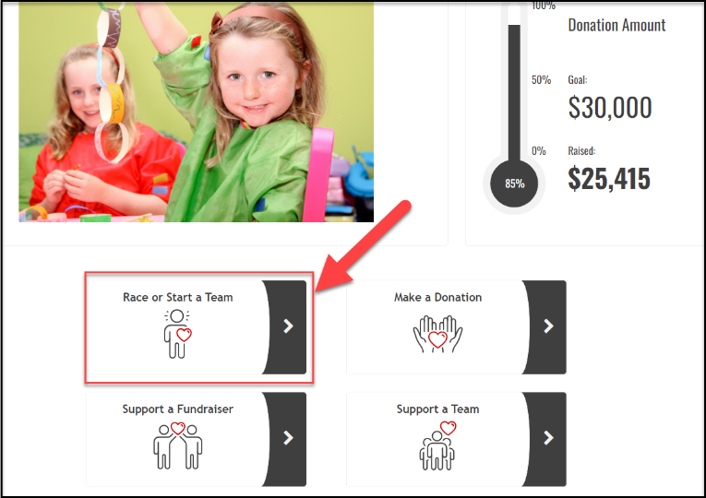
- A new page will open to allow you to select your ticket levels.
- Choose the appropriate level and any add-ons (if applicable).
- Select the number of each ticket level you are registering for in the QTY field.
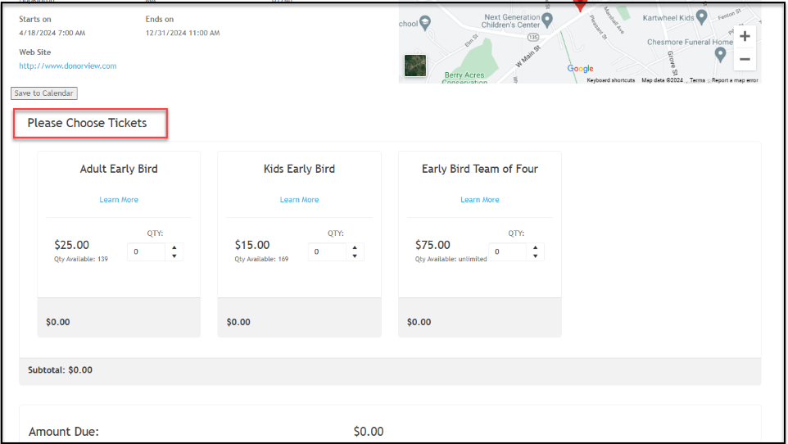
- You can join an existing team or start your own team.
- If you are just signing up for yourself and not creating or joining a team, you can skip over the team section and proceed to completing the information about the participants.
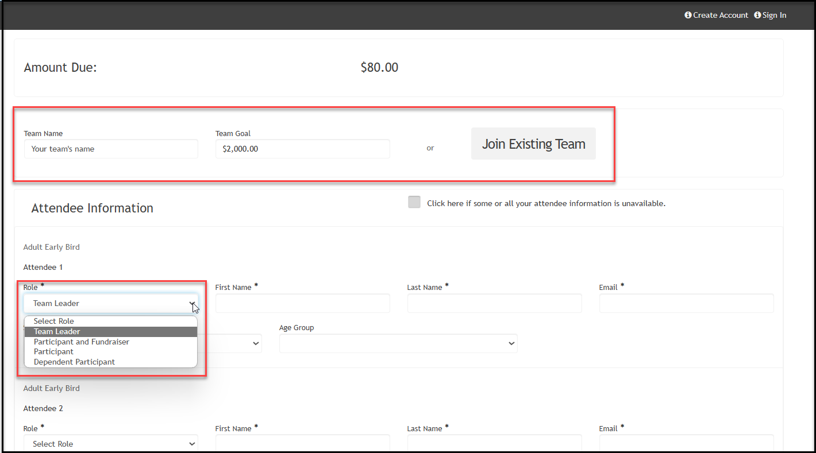
- For each person you are registering for, provide their contact information and answer the questions.
- Assign each participant a role. INCLUDE THE APPROPRIATE ROLES
  - Team Leader – if teams are formed, the team leader can manage their personal fundraising page as well as the team fundraising page.
  - Participant Fundraiser – a participant who is fundraising and has their own fundraising page.
  - Participant –this person is only participating in the event and does not have a personal fundraising page.
  - Dependent participant –this person is participating in the event, but does not need to provide contact information, just a name. This is most often used for children.
- At the bottom of the page, include the billing and contact information for the person or organization paying for the registration.
- When you click submit, you will be directed to the donor portal to create your fundraising page. The name and email you used to sign up with auto-populate on the page.
  - If you already have a portal account, you can click on SIGN IN or Already have an account, click here to login to your existing account.
  - If you do not have an account, you will create a password, then re-enter your password and click on the orange Sign Up button.
  - From the sign in page, enter your email and password and click on Sign In.
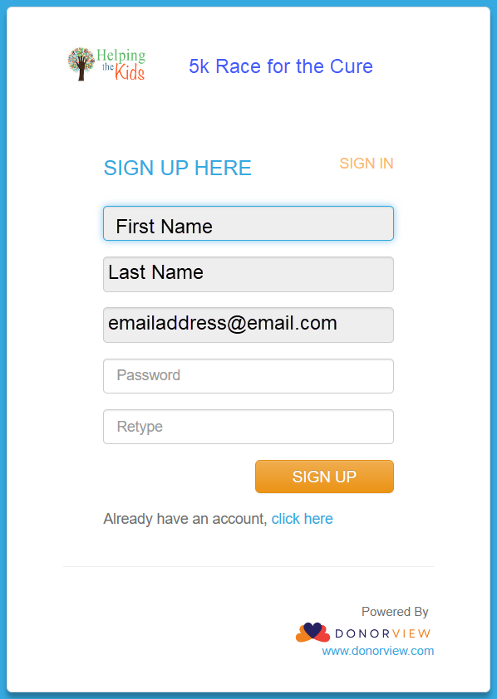
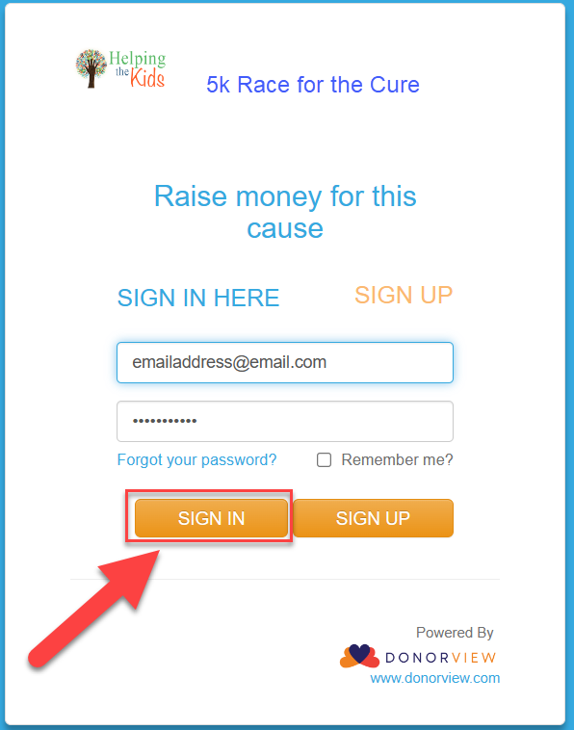

Creating Your Fundraising Page(s)
- When you enter the portal, you will be able to create your personal page first.
- If you are the team leader, you must create your personal page before your can create your team page.
- If you have not joined a team, after you create your personal page, you have the opportunity to join a team if you’d like to.
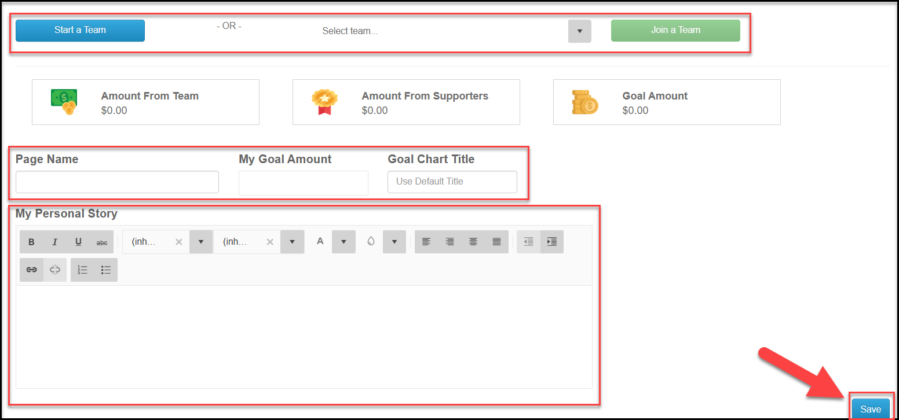
- Enter your page name, goal amount, a goal chart title, and your personal story. You can edit these anytime. Click the blue SAVE button to create your page.
- With your new page created, you can share the URL link to your page, download a QR code to share, and, if enabled, you can create a text code.
- Your personalized text code is an alpha-numeric code word (no spaces) that donors can text to the nonprofits text-2-give phone number XXX-XXX-XXXX and the donor will receive a link back to your fundraising page to make their donation using their phone.
- After the page is created, you also have the option to update the color theme.
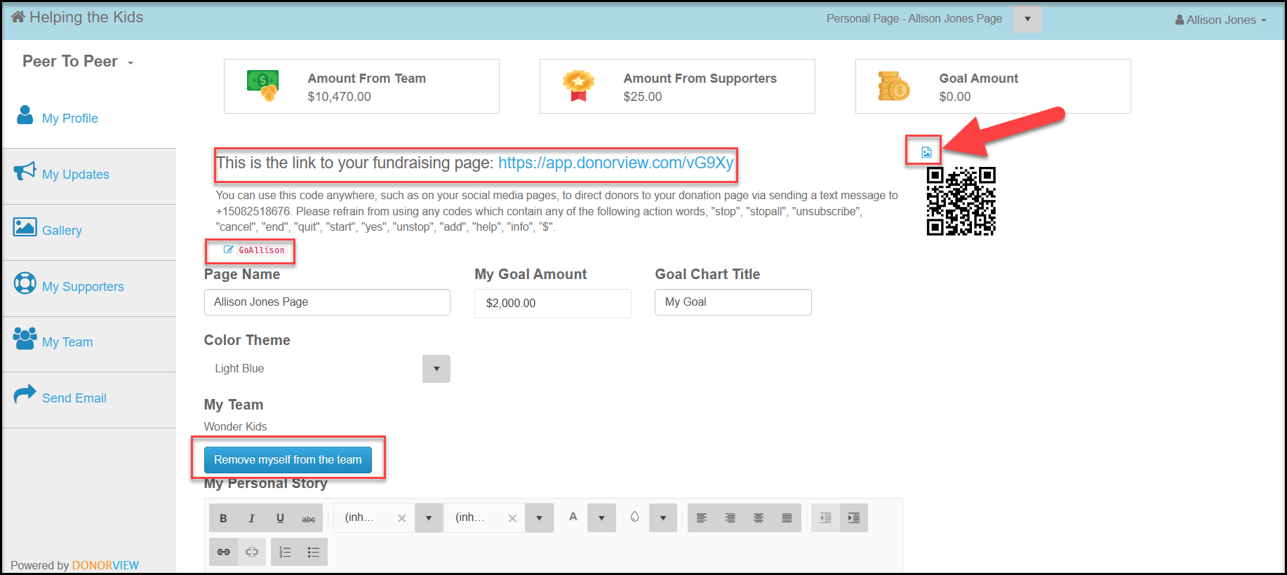
- Scroll to the bottom of the page to see a preview of your page and edit as needed, clicking on the blue Save button after any changes.
- Click on the link to you page to see it live.
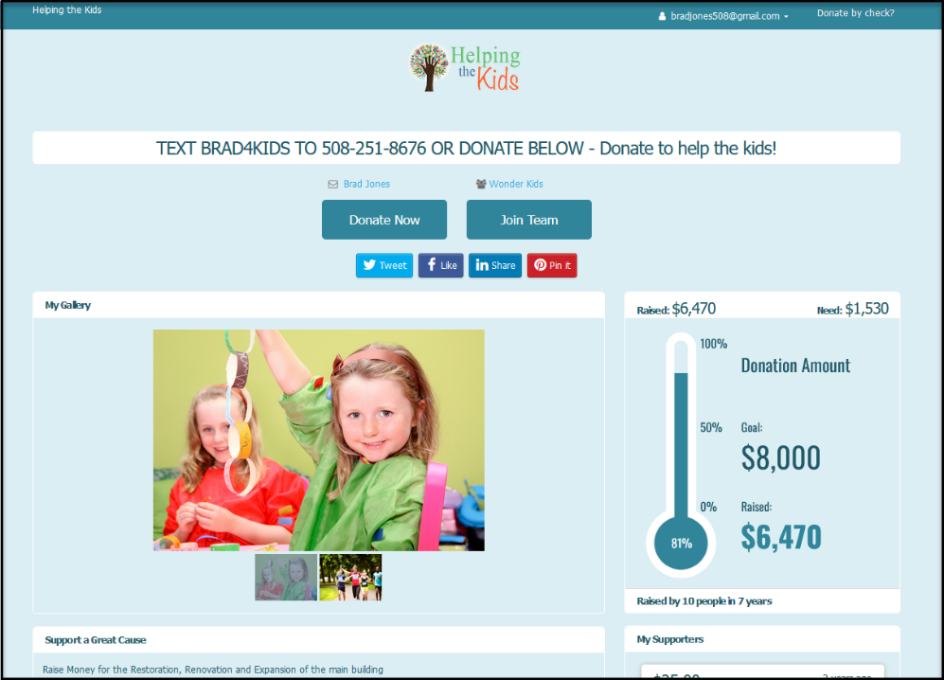
- If you are the team leader, you can see the team you created using the page menu at the top of the page.
- Clicking on the team name will allow you to edit the page as above.
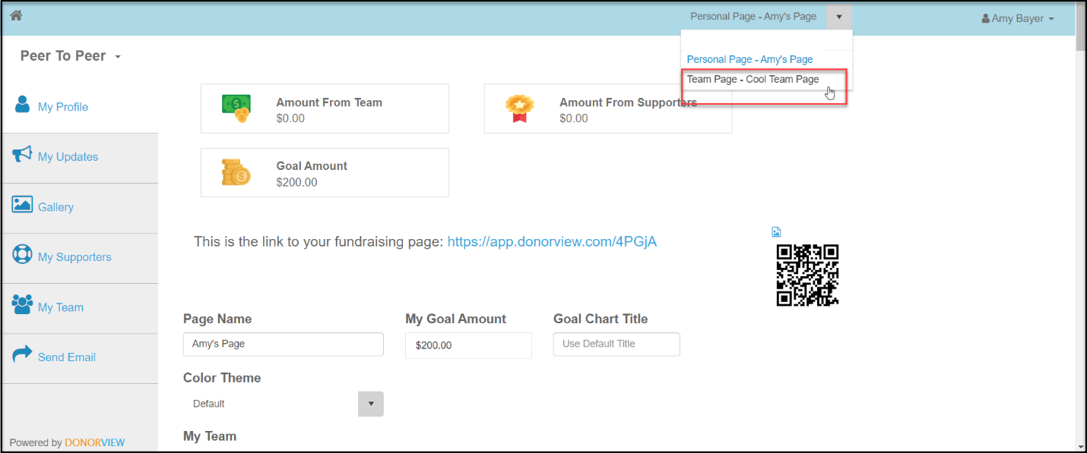
- If your team has not been created yet, click on the blue Start Team button.
- Enter the team name and goal for the team and click the blue Save button to create the team page.
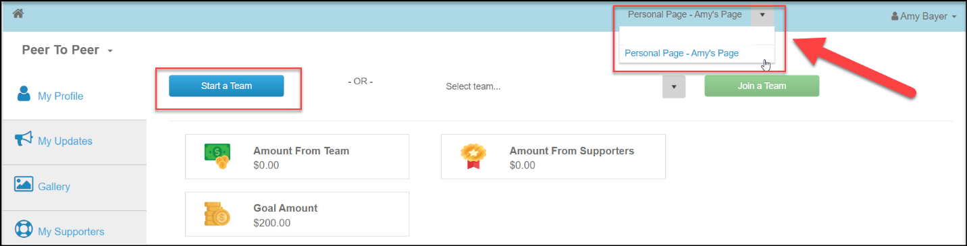
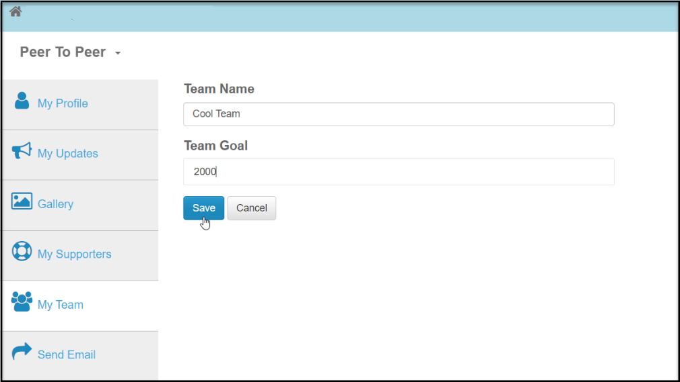
Customizing and Sharing Your Fundraising Page(s)
- The menu on the left side of the page allows you to customize information and communicate with donors and potential donors.
- You can add your own updates to your page using the My Updates link.
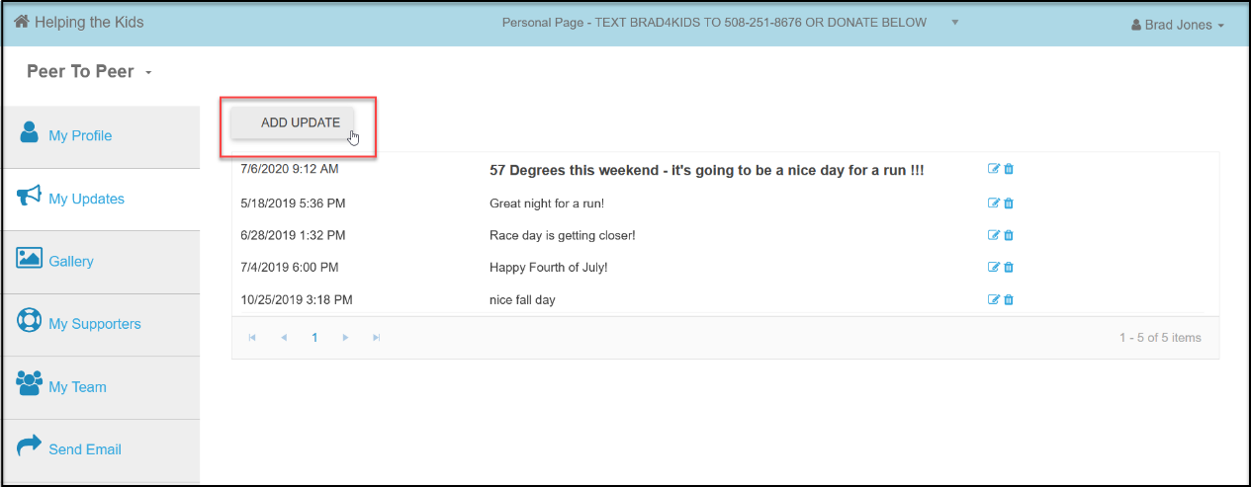

- You can upload your own photos and a YouTube video using the Gallery link.
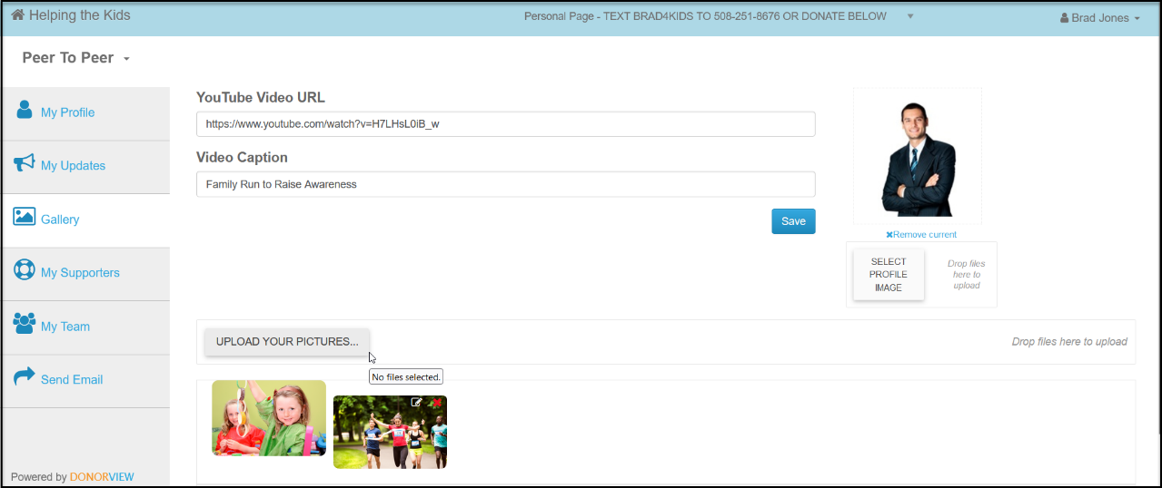

- When donations are made on your pages, you can see information about the donors and even send them messages using the My Supporters link.
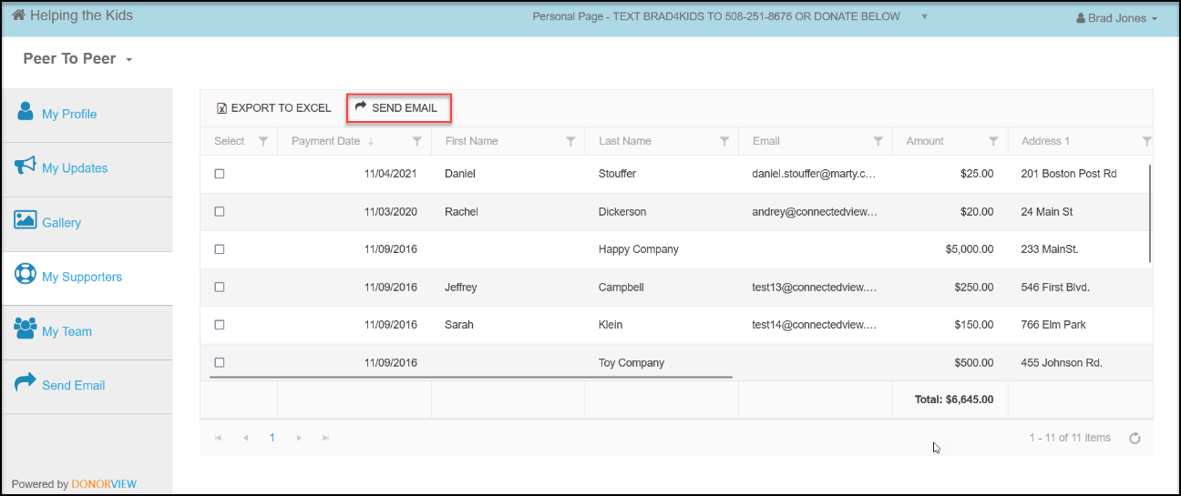
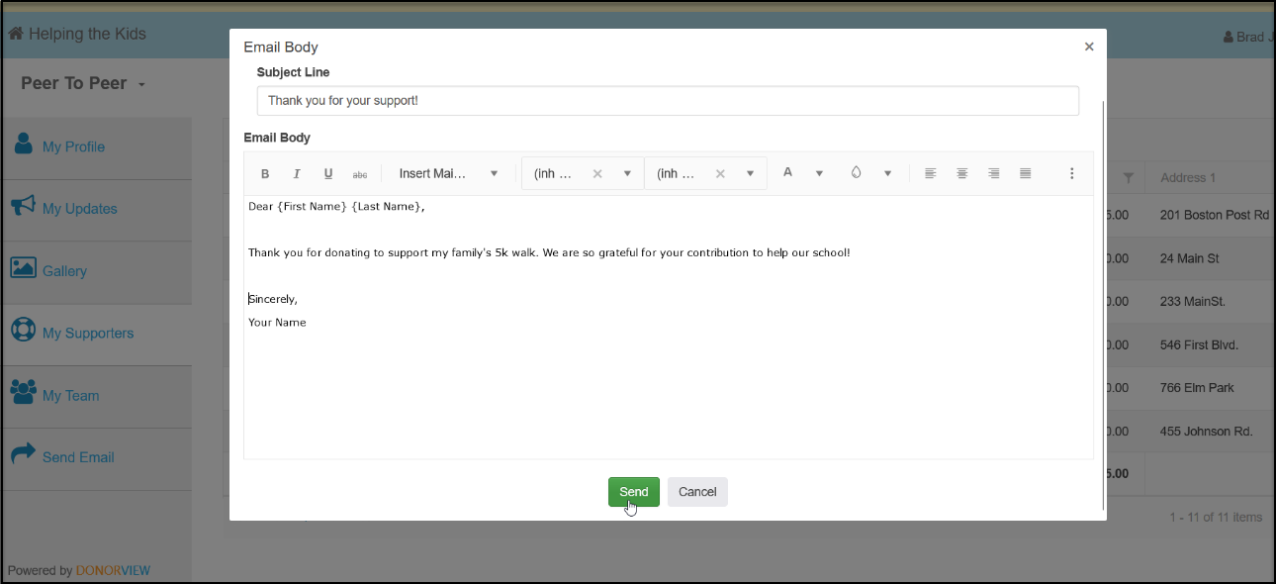

- You can see how your teammates are doing with their fundraising in the My Team link.
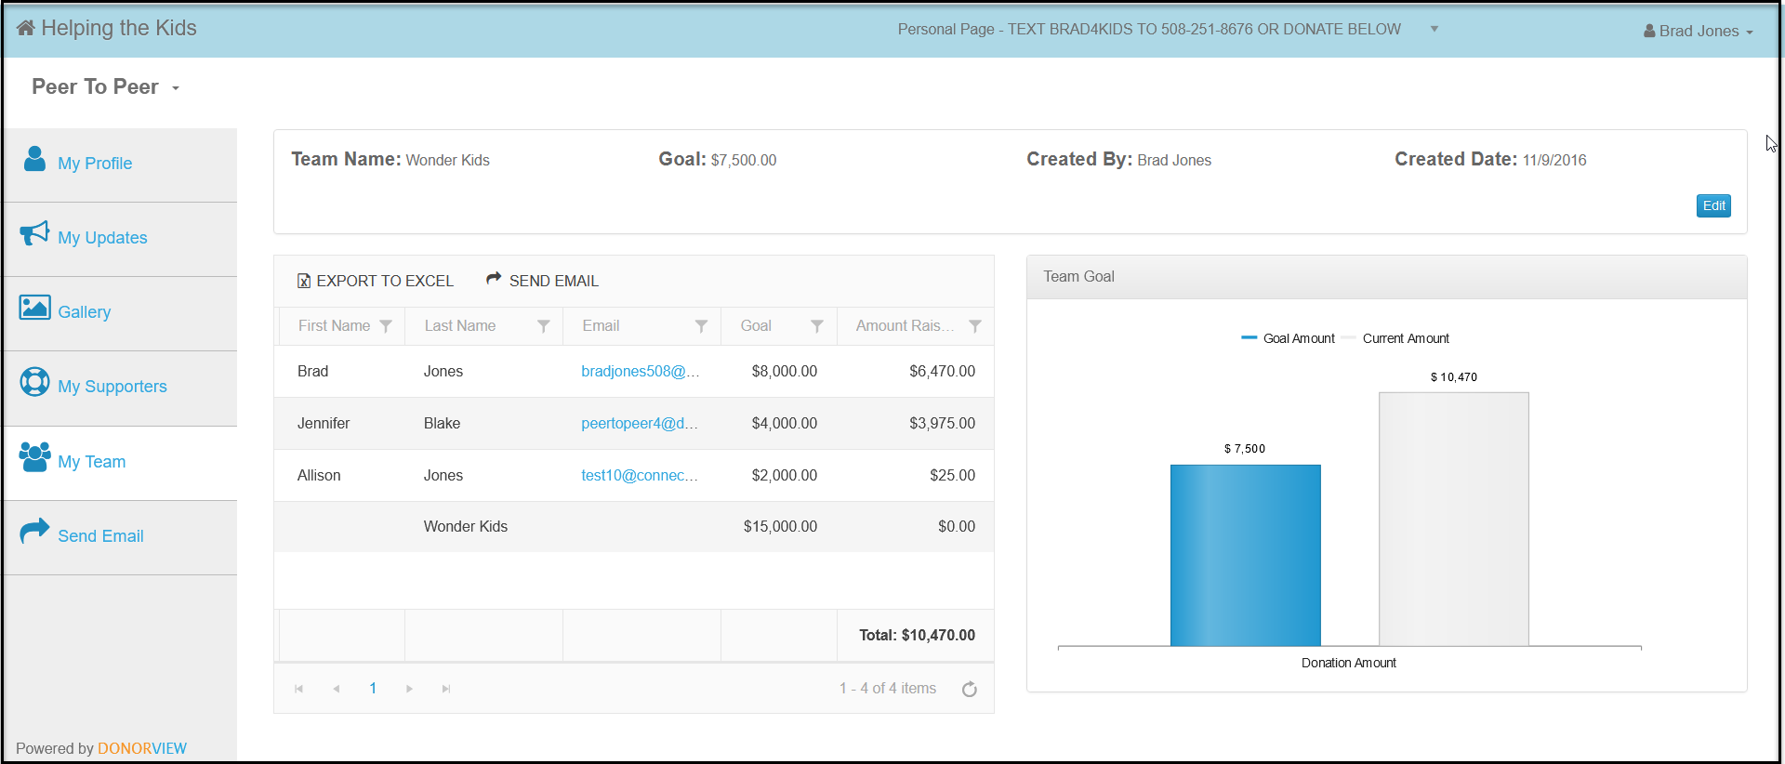
- You can also share your links and send emails to your friends and family from the portal. The emails are sent under blind copy, so you don’t have to worry about anyone seeing any email addresses.
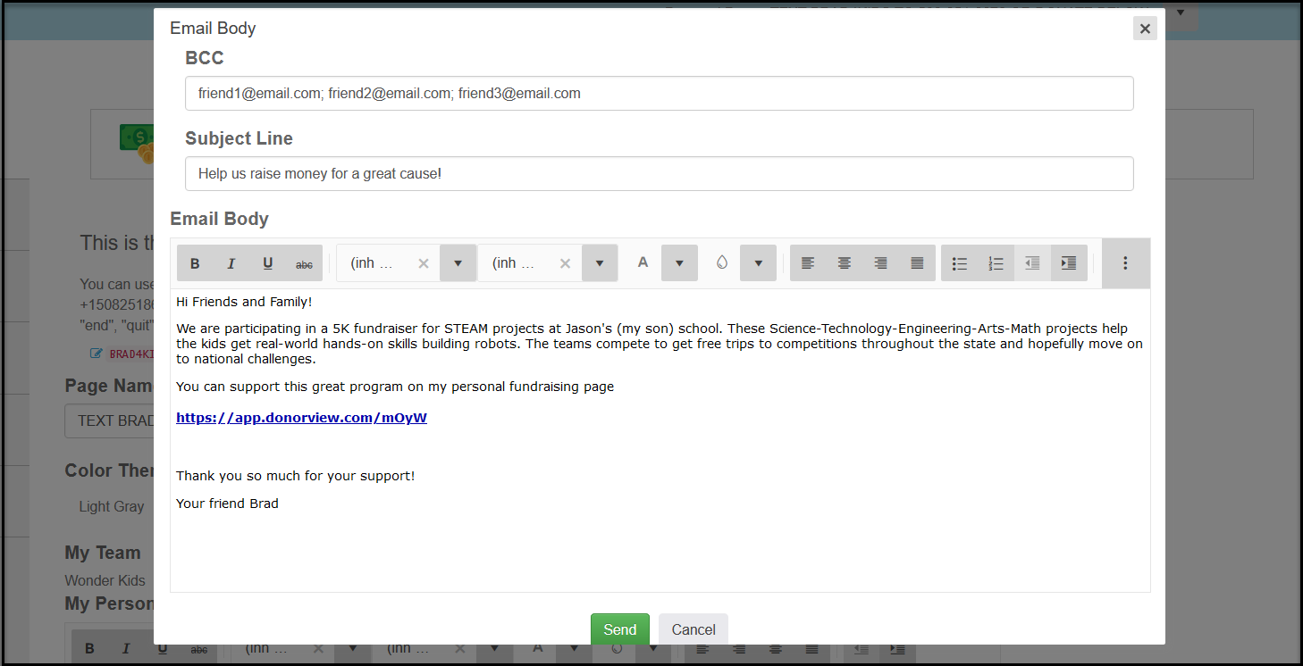
- You can also share your page links via your personal email, social media, and text messages.
- INSERT ORGANIZATION NAME will be recognizing our top teams and fundraisers by INSERT YOUR MILESTONE AND BADGE PROGRAMS AND ANY PRIZES.
- You can see how the other teams and fundraisers are doing on our website at INSERT YOUR WEBPAGE WHERE THE PROGRESS WIDGETS WILL BE SHARED.

