Event’s Page Feature to also add to Donation Page

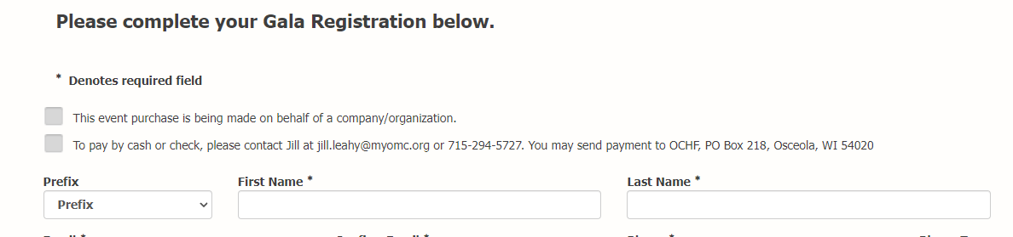
Drop down on Donation Page should also have the ability to choose multiple as a check box instead of drop down.
