The first step in creating a report and using the export to existing file functionality is to filter your grid for the data you want. This example uses the Constituent Grid where the filter will be all constituents by State.
Click on the filter – State on the left side and choose CA
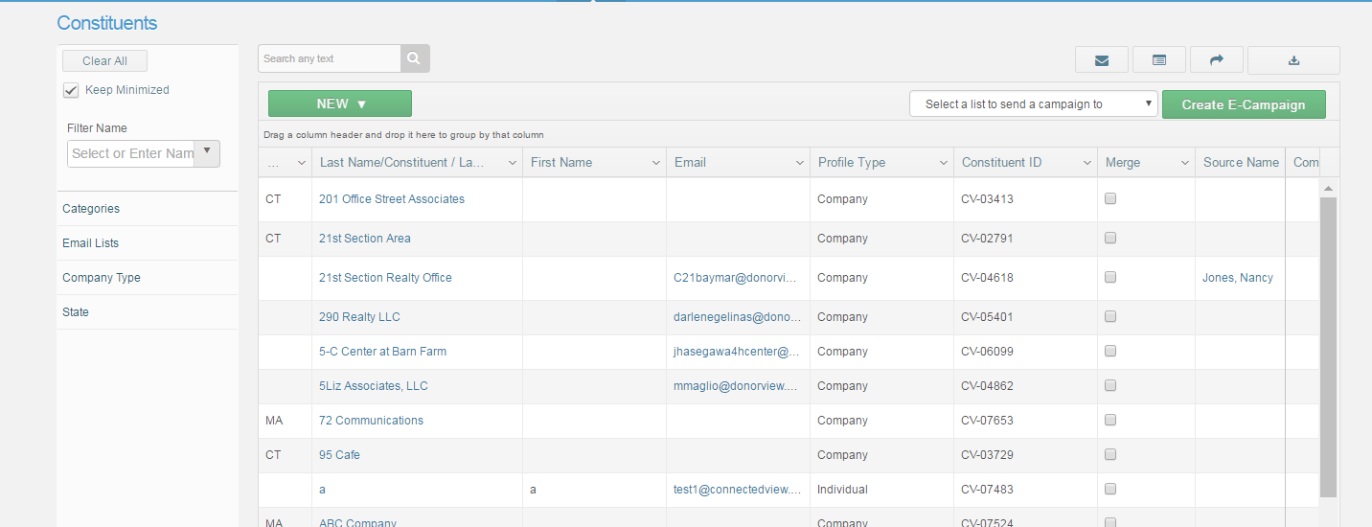
This will return all the constituents where the state = CA
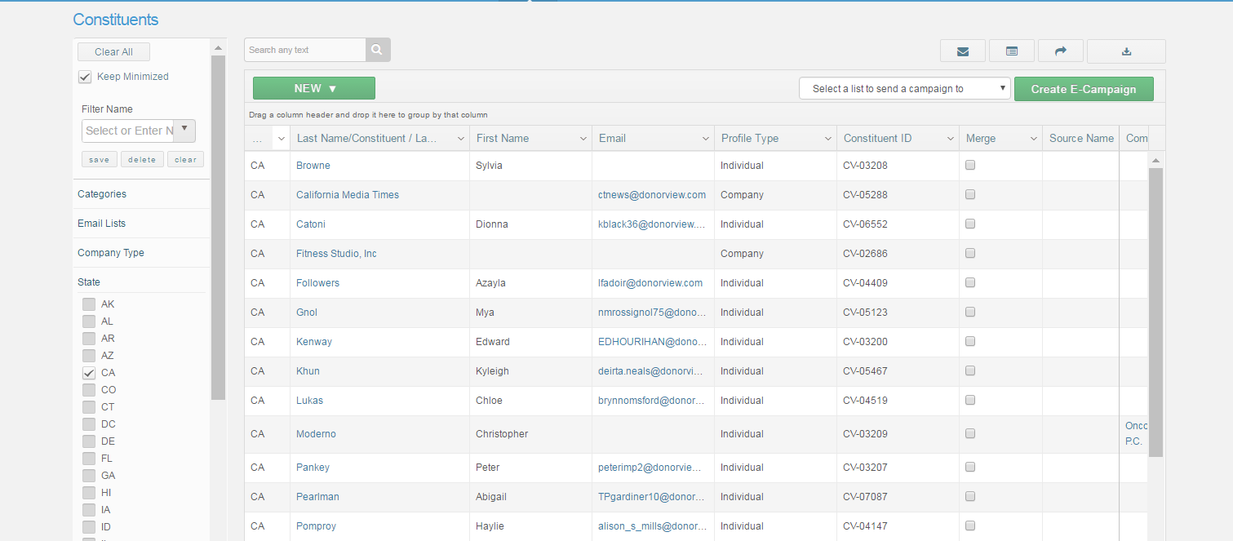
Click on to export the data to excel. And excel file will download in the bottom left corner 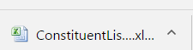
Click to open the file in excel

The raw data is returned to excel like this and will have all the fields on the grid.

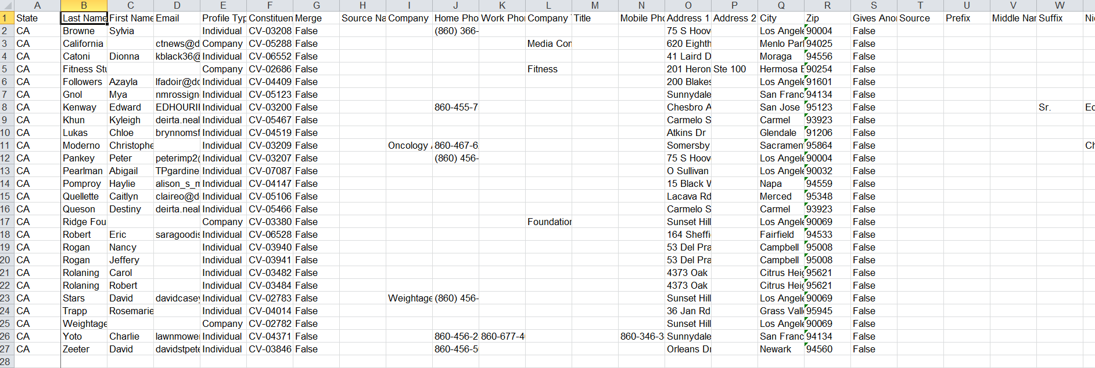

Here you can format the report as you wish. In this example –columns not needed were hidden, the font was changed and the header was bolded.

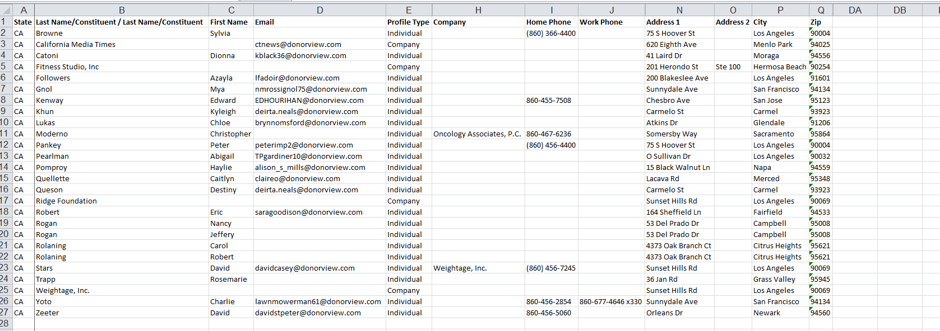

Once all the changes are made – save (save as to use your own report name) the report – in this example it is being saved as CA Constituents.
Return to DV – filter the grid for CA again or you can save the filter – by giving it a filter name in the Filter Name field and Save

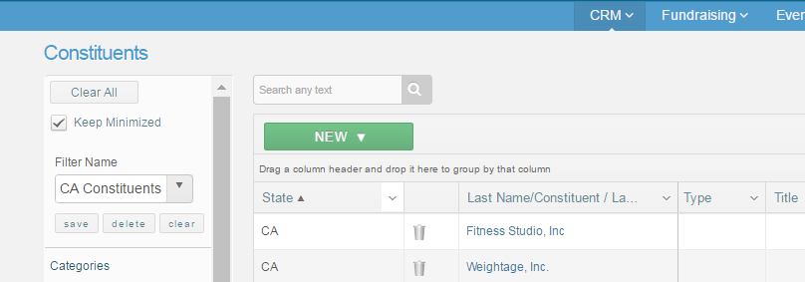

then click on the Export to Existing File – navigate to the CA Constituents Report then open the report
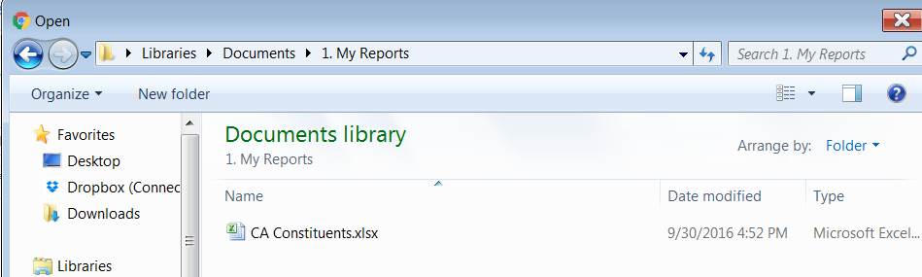
The formatting changes are saved and in this example a new constituent in CA was added (in yellow)
