Table of Contents
Pre-Event 2
What are the benefits of using a P2P campaign instead of sharing a donation page link? 2
What training videos and instructions are available for me to prepare for my campaign? 2
Do I have to activate the advanced portal to host a P2P campaign? 2
Creating the Campaign 2
Why are there three date ranges associated with a P2P campaign? 2
Can I prevent teams from being created? 4
What if we only want teams and no individual fundraisers? 4
Can I put a cap on the number of team members? 5
How do I share the campaign with prospective fundraisers? 5
How can I link a survey to a P2P campaign if I need more information from the fundraisers? 5
Linking to an Event 6
What if I have event levels that don’t need to create portal fundraising pages, like sponsorships? 6
What if some people want to participate in the event, but not be a fundraiser? 6
What if there are kids participating in the event and we don’t need to get their contact information? 6
If I’m having an event, do I have to link the P2P campaign to the event page? 7
Supporting Fundraisers 7
Are there any documents I can share with my fundraisings to give them instructions? 7
Can I login and see a fundraiser’s portal? 7
Can someone participate who doesn’t create the page in the portal? 8
Can participants create their own text-2-give code? 8
What if someone wants to change teams? 9
How can I change the role that someone has for a team – make a new team leader? 9
Can I deactivate a participant? 10
Pledges and Donations 10
Can I link a donation page to a P2P campaign? 10
Can I get a notification if someone makes a donation? 10
What if I need to change the participant or team that is getting credit for a donation? 11
How do I collect the payments for pledges made? 12
Communications 12
How can I reach out to the fundraisers? 12
What are the benefits of milestones and badges? 12
What kind of milestones and badges can I create? 13
How can I notify fundraising participants when they haven’t reached their goals? 16
What are the options for sending thank you acknowledgments to P2P donors? 16
Reporting 17
What is the difference between the Summary View and the Detail View on the P2P Dashboard? 17
How do I see all the donations for a P2P campaign? 18
How do I see the money raised by the team? 18

Pre-Event

What are the benefits of using a P2P campaign instead of sharing a donation page link?
- A Peer-2-Peer (P2P) campaign is designed to allow you to see all of the donations related to a specific fundraiser or team on the P2P Dashboard.
- P2P campaigns let you recognize participant fundraisers when they reach certain milestones defined by you - which is a great way to keep them engaged in the process.
- The P2P campaign pages include widgets like overall progress on goal, top participants, and top teams to be able to share on your website.
- The P2P campaign allows fundraisers to create their own personal pages and share their personal stories, images, and updates.
- The participants can also see who has contributed to their page and communicate with them via email.
- Participants can also create their own text-2-give codes to share with their friends and family and allow easy donations via text links.

What training videos and instructions are available for me to prepare for my campaign?
  - Peer to Peer Fundraising - https://vimeo.com/197190005 (Password: DV2017)
  - Peer to Peer Event - https://vimeo.com/763864527 (Password: DV2017)
  - P2P Campaigns Guides and Checklist Support Article – https://support.donorview.com/en/support/solutions/articles/9000236877-p2p-guide-and-checklist
  - Participant Fundraisers Guides – https://support.donorview.com/en/support/solutions/articles/9000236807-are-there-instructions-for-fundraisers-to-set-up-their-pages-
  - General Peer to Peer Support Articles - https://support.donorview.com/en/support/solutions/folders/9000161307
  - Managing the Portal and Portal Users Support Articles - https://support.donorview.com/en/support/solutions/folders/9000175741

Do I have to activate the advanced portal to host a P2P campaign?
- No, the advanced portal does not need to be activated for a P2P campaign.
- The standard portal is active for any P2P campaigns or auctions.

Creating the Campaign

Why are there three date ranges associated with a P2P campaign?
- The three dates allow you to customize when the pages are visible to the public and to fundraisers.
- At the top of the P2P Campaign Settings tab enter the Event Start Date and Event End Date if the P2P is linked to an event. If it is not linked to an event, you can leave those fields blank.
- The Fundraising Begin Date and Fundraising End Date fields are the dates that donations can be made on the participant’s pages.
  - Outside of these dates, the pages are not viewable by the public.
  - Fundraising usually begins before the event start and can extend past the event end date.
- The Active to Participant Begin Date and Active to Participant End Date are the dates that the pages are viewable to the participant fundraisers from the portal.
  - Outside of these dates, the pages are not editable or sharable.
  - The participants typically have some time to update their pages prior to beginning the fundraising and keeping it open after the end of the fundraising allows them to send thank you messages to donors and team members and see final results for their personal and team pages.

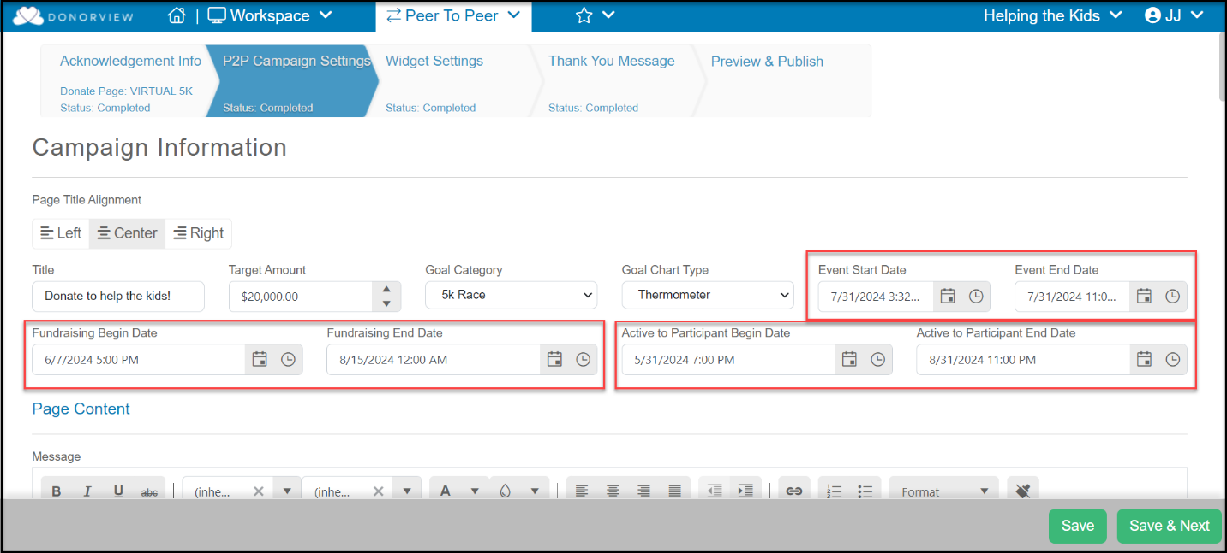

Can I prevent teams from being created?
Yes, you can disable teams from both the P2P Campaign Settings and, if linked to an event, from the Events Settings tab.
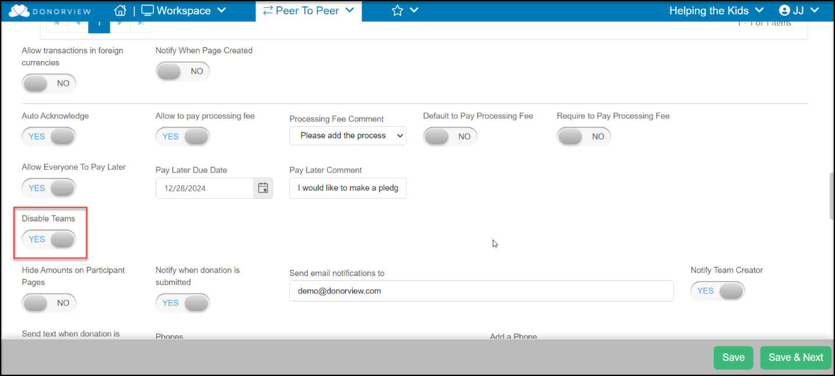

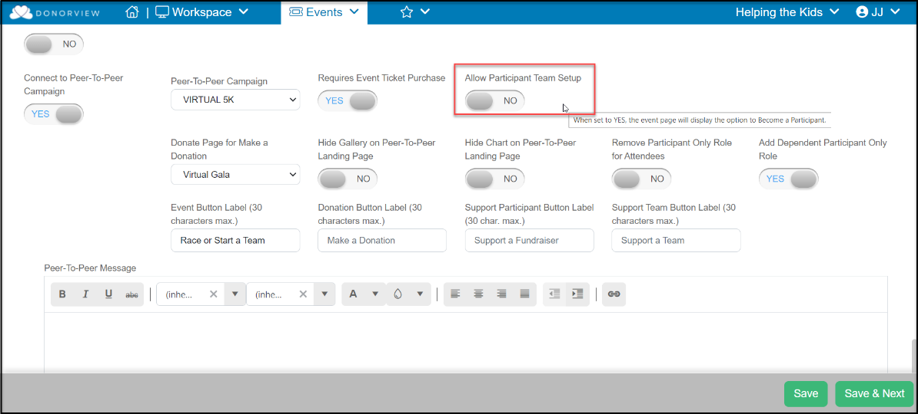

What if we only want teams and no individual fundraisers?
- Currently, there is no way to disable individual participants pages and only have team pages.
- An individual participant must create their page first, before a team page can be created.
- You could provide instructions to your participant fundraisers to only share the team page link.
- Alternatively, you could also disable teams and only have one participant fundraiser create a page and label it with a team name.

Can I put a cap on the number of team members?
- Yes, you can limit the number of members on a team from the P2P Campaign Settings page.
- When the number of members is reached, that team is no longer visible in the list of teams available to join from the event sign up page.
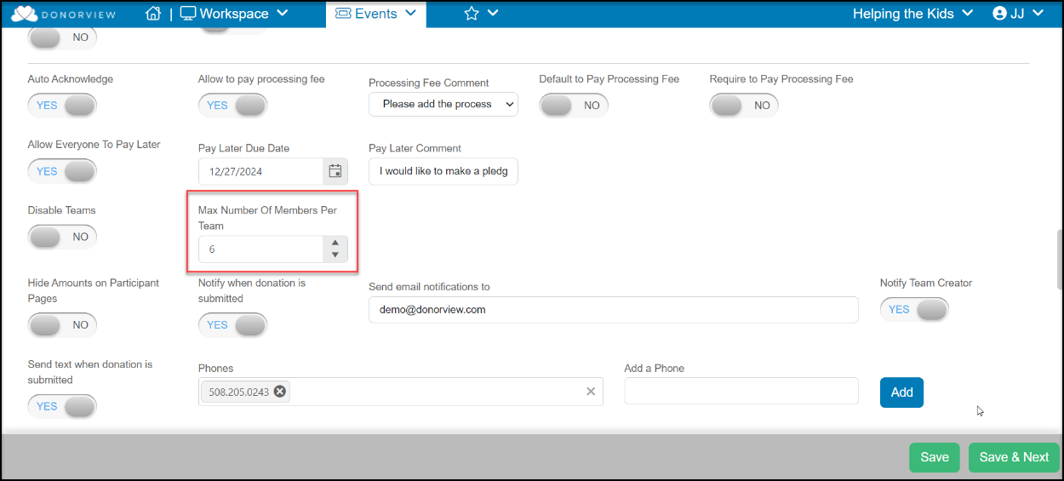

How do I share the campaign with prospective fundraisers?
- If it is a non-event P2P campaign, you can share the URL or QR code on the Preview & Publish tab.
- You can also share the P2P campaign URL or QR code if you are not requiring a ticket purchase or event registration to become a fundraiser.
- For P2P campaigns linked to an event where the fundraiser needs to register or purchase a ticket, share the URL, Text, or QR code from the event page.
- You can share the links via an email marketing campaign, direct email or text message, or by inserting the links or QR codes in a mail merge letter.

How can I link a survey to a P2P campaign if I need more information from the fundraisers?
- You can consider two workflow options, to send the survey prior to the P2P signup or after.
- If you need to collect information as a screening process prior to the participants accessing the campaign sign up, then create a survey and send it to prospective fundraisers.
  - If you need to review the survey information prior to releasing the information, you can use the Enable Internal Review feature to screen the candidates.
  - If you do not need to screen the candidates, you can include the link to register for the P2P campaign or event page in the survey’s thank you message.
- If you do not need to collect the information prior to the campaign or event sign up, you can include the link to the survey as part of the initial invitation message, or if the P2P campaign is linked to an event, you can include it in the registration thank you message.

Linking to an Event

What if I have event levels that don’t need to create portal fundraising pages, like sponsorships?
- The decision on how to include options to participate or support an event depends on whether or not their support will include admission or participation in the event.
- If admission or a ticket to participate in the event is NOT included in the sponsorship, you could make it an event add-ons.
  - Add-on purchases are not included in the event attendance list.
  - If only add-on purchase are selected, there will be no request for attendee information or a link to create the portal fundraising page.
- If the event level, like a sponsorship, does include some admission to the event, you could also provide instructions in the Page Content & Display Options for them to select Participant or Dependent Participant roles for any of the included attendees.
- You also have the option to create a separate donation page or event page specifically for sponsorships that is not linked to the P2P campaign if desired.
- Note that if a separate sponsorship event page is created, any sponsor’s attendees will be listed only under that sponsorship event in the Event Attendance grid. You cannot view two events at one time in the Event Attendance grid.

What if some people want to participate in the event, but not be a fundraiser?
- Use the Participant only role to participate in the event, but not create a fundraising page.
- A person with a participant only role still needs to provide an email address.
- A person with a participant only role can also be included as a member of team, but not have their own fundraising page.

What if there are kids participating in the event and we don’t need to get their contact information?
- For participants that you do not need to communicate with directly, like children, you can activate the Add Dependent Participant Only Role by selecting the toggle to YES.
- Dependent participants will be shown in the Event Attendance grid but will not have a constituent profile record created.
- Dependent participants are still counted in the total number of constituents.
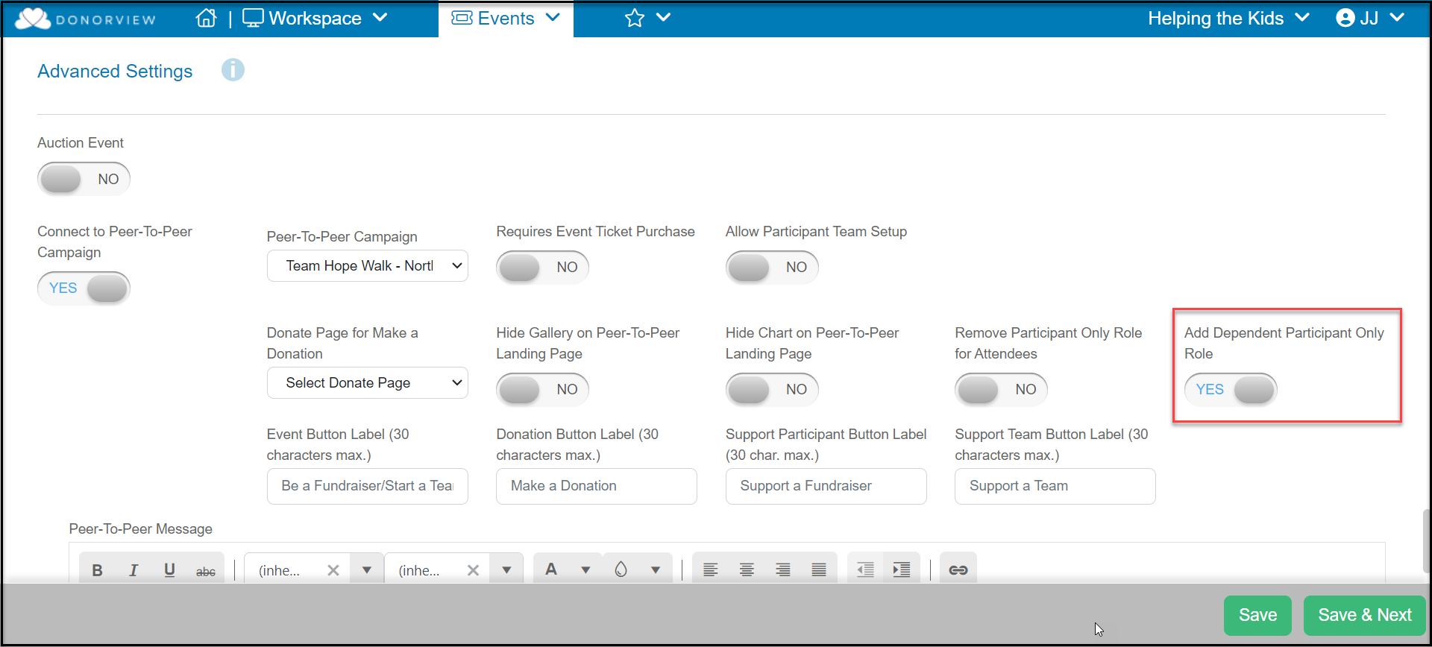

If I’m having an event, do I have to link the P2P campaign to the event page?
- No, there is not a requirement to link a P2P campaign to an event, even if the campaign is intended to support the fundraising efforts tied to that event.
- By default, when setting up an event that is linked to a P2P campaign, if you turn on Capture Attendee Info under the Attendee Info tab, one of the roles can be participant only, which would not include the link to set up a portal account.
- If you would like to make participation in the P2P portion optional, you could also choose not to link it to the event and instead include the link to the P2P campaign in the event registration thank you message.

Supporting Fundraisers

Are there any documents I can share with my fundraisings to give them instructions?
Yes, there are two documents available for you to update and use as your own instructions available in the support articles here: https://support.donorview.com/en/support/solutions/articles/9000236807-are-there-instructions-for-fundraisers-to-set-up-their-pages-

Can I login and see a fundraiser’s portal?
- Yes, from the Portal Users grid located in the menu under your organization’s name Users>Portal Users.
- Click on Sign In to log out of the back end of DonorView and login to the portal as that constituent.
- You will be able to make changes and edits to the fundraiser’s page or see any issues they may be having.
- You should use the Log off feature under the constituent’s name in the top right corner of the page.
- You will need to log back into the DonorView platform.
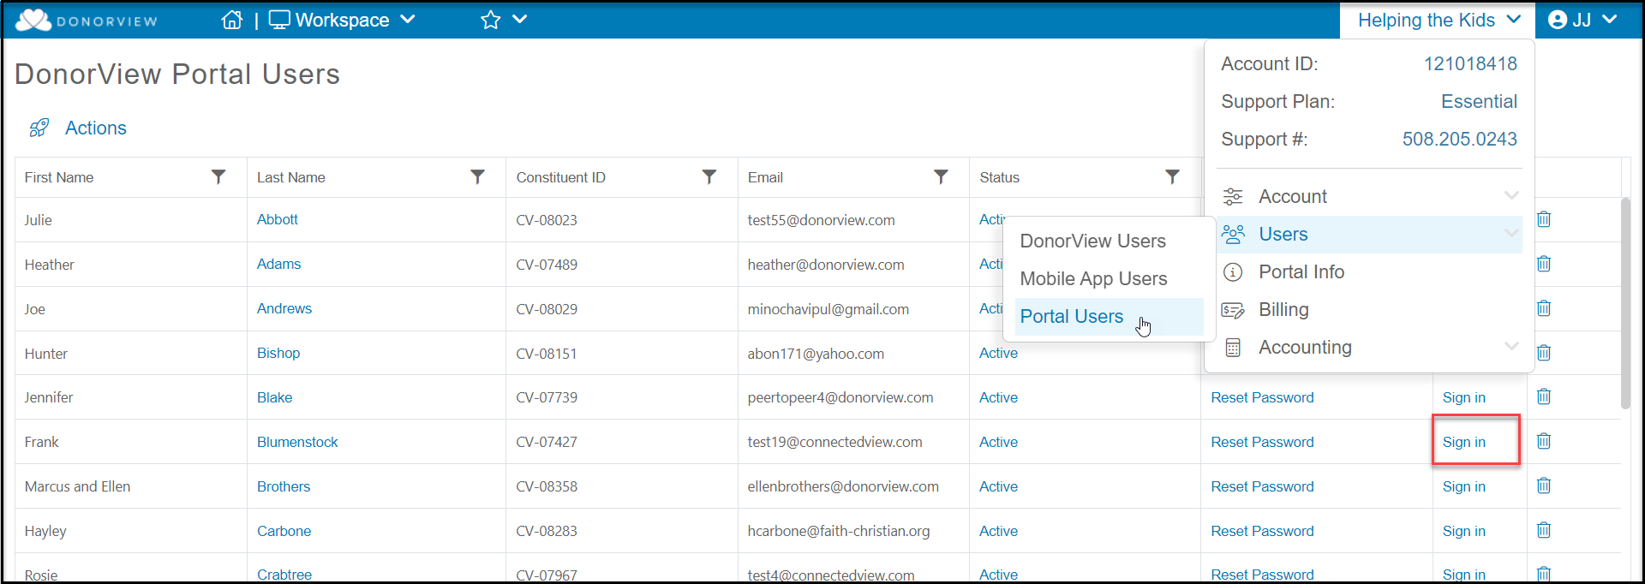

Can someone participate who doesn’t create the page in the portal?
- In order to be listed as a participant fundraiser, a fundraising page must be created in the portal.
- You can log into the participant fundraiser’s portal account and create their page on their behalf. This way their name would also be shown on the participant fundraiser’s list.
- The person could also share another team or person’s fundraising page link; however they will not receive credit for the donations. The credit will go to the team or person’s page where the donation is made.

Can participants create their own text-2-give code?
- Yes, but you will need to enable that feature on the P2P campaign Settings Tab.
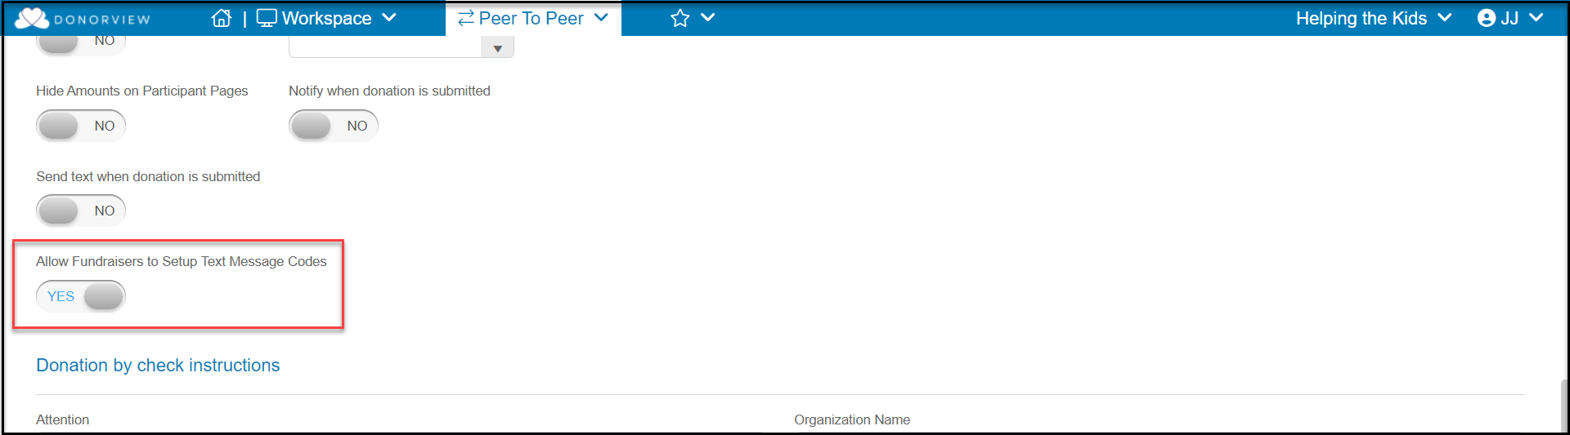
- After they create their page, they can click on the edit icon under the text paragraph to customize their own text code.
- Donors can text that alpha-numeric code to your organization’s text phone number and receive a link back to the that fundraiser’s mobile optimized page.
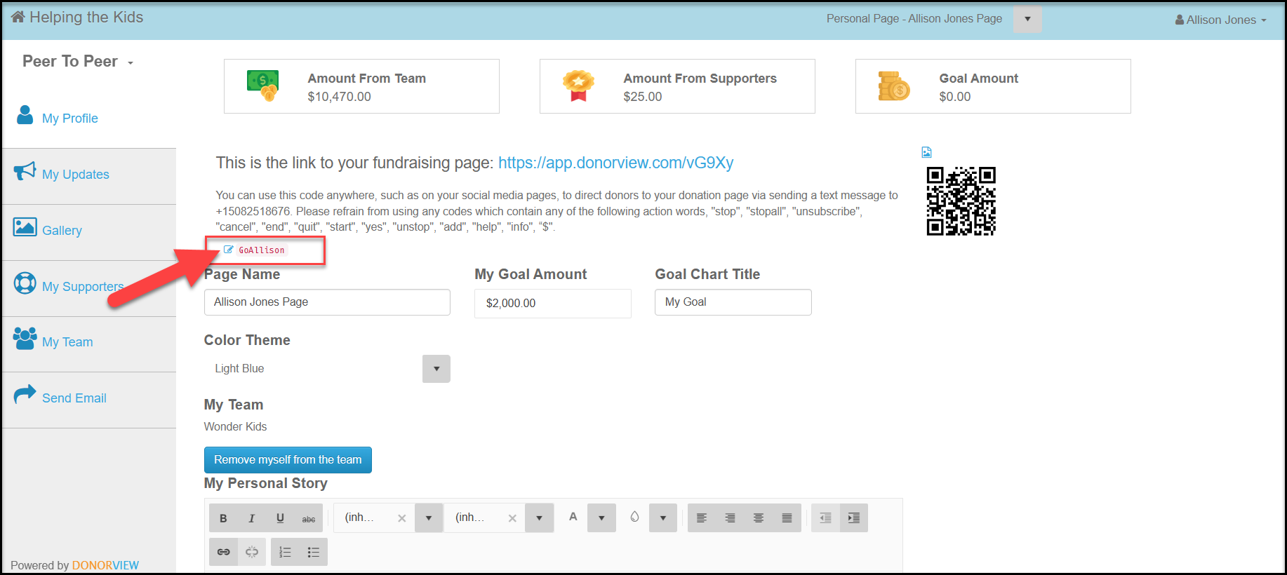

What if someone wants to change teams?
- From the participant fundraisers portal page, they can click on the blue button Remove myself from this team.
- Any donations made to this fundraiser’s page will be removed from the team’s total.
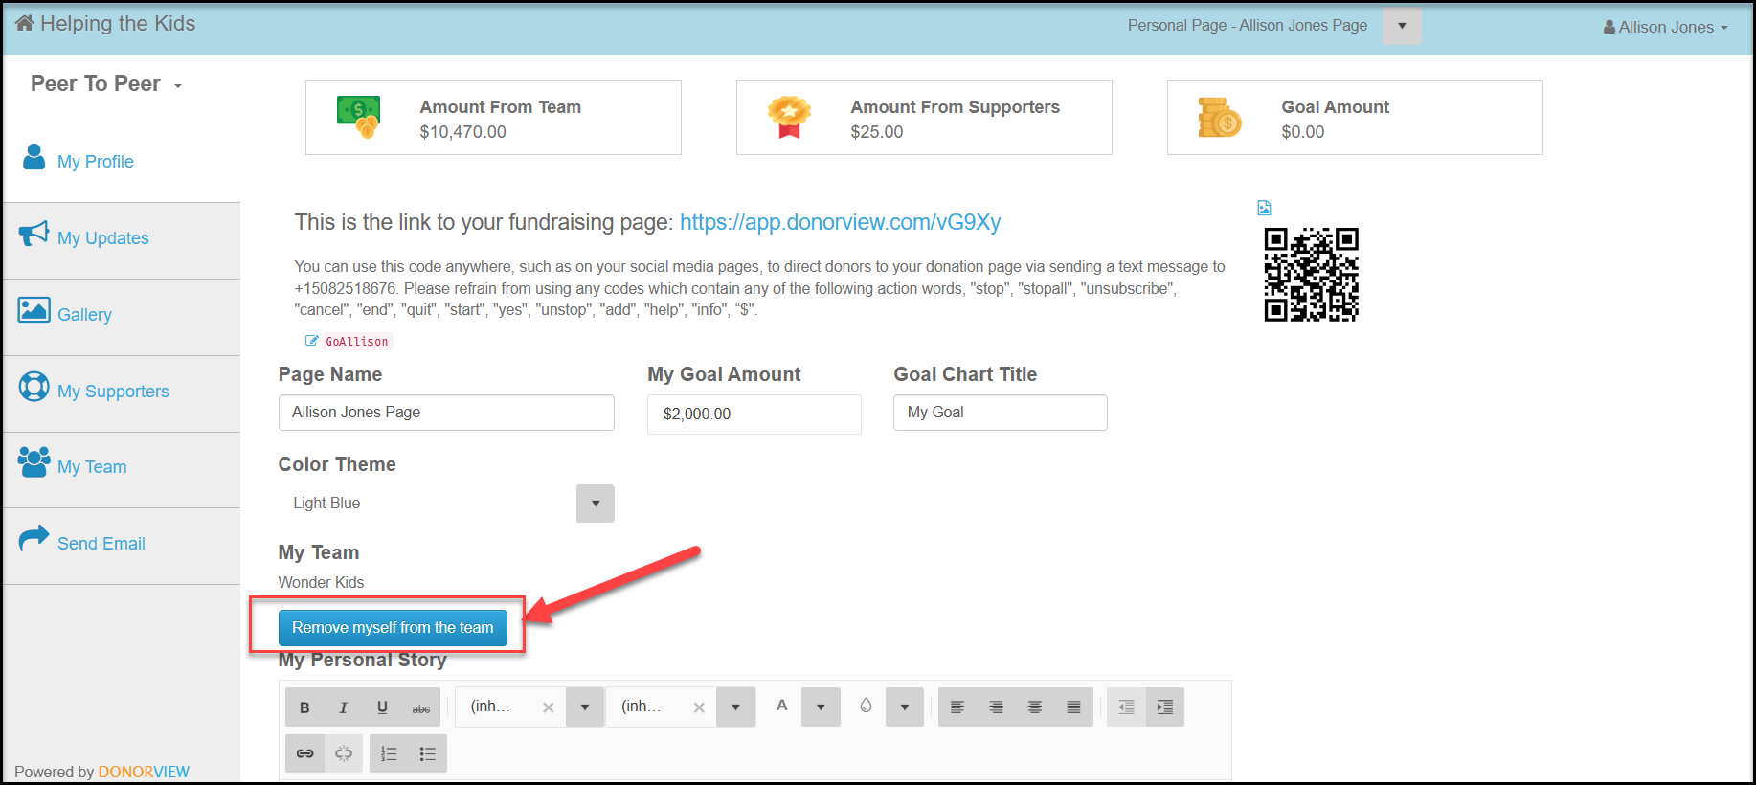

How can I change the role that someone has for a team – make a new team leader?
- If a team leader can no longer participate, there is not a direct way to assign a new team leader.
- However, you can have the other team members remove themselves from the team and the new team leader will create a new team.
- Once the new team is created, the other members can join the new team.

Can I deactivate a participant?
Yes, from the P2P Dashboard, click on the link on the left side of the grid. Type YES in the new window to delete the page and remove the participant’s link to the team as well.
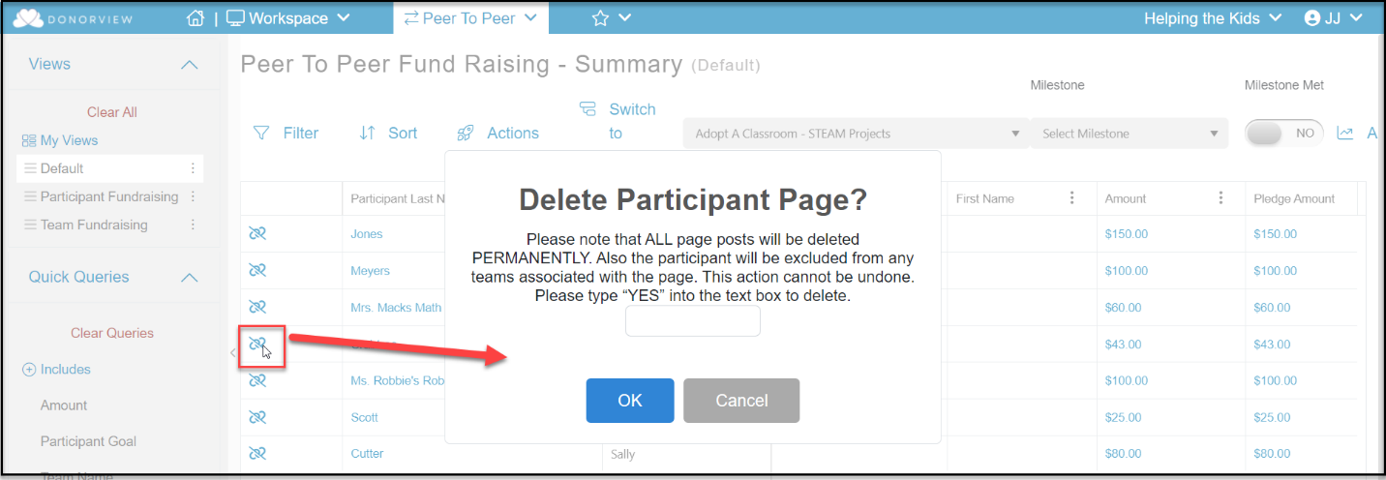

Pledges and Donations

Can I link a donation page to a P2P campaign?
Yes, in the Additional Options section at the bottom of the Donation Page Settings tab, you can link your donation page to a P2P campaign so that donors can choose a participant or team to support.
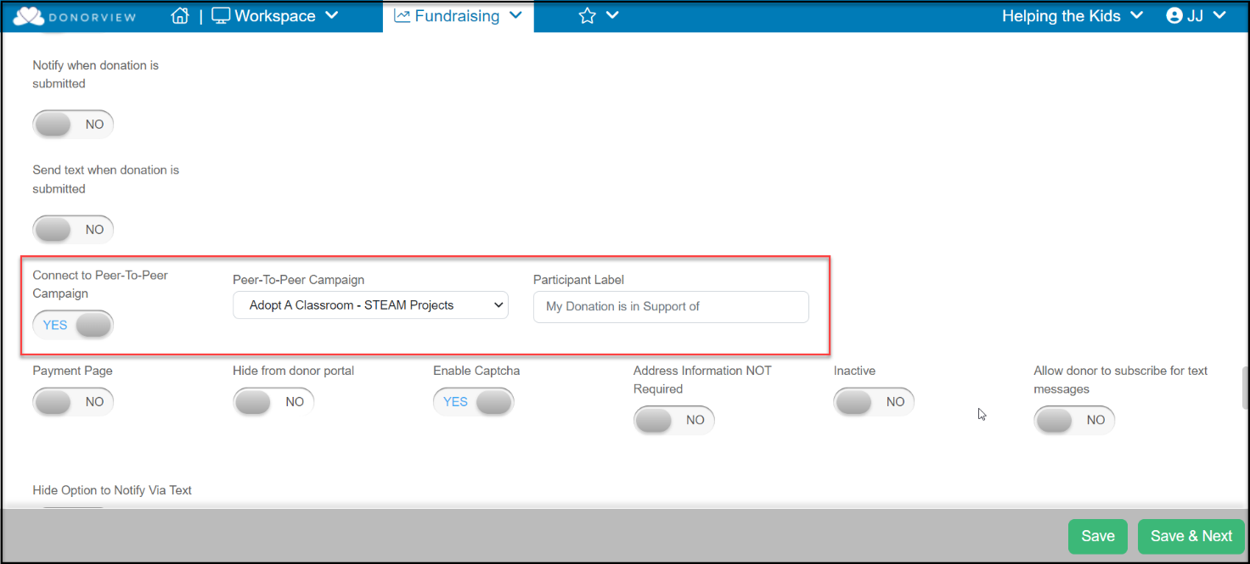

Can I get a notification if someone makes a donation?
- Yes, up to 5 emails can get a notification every time a donation is made by toggling Notify when donation is submitted to YES on the P2P Campaign Settings tab.
- The fundraiser and the team leader can also get a notification by activating the toggle Notify Team Creator to YES as well.
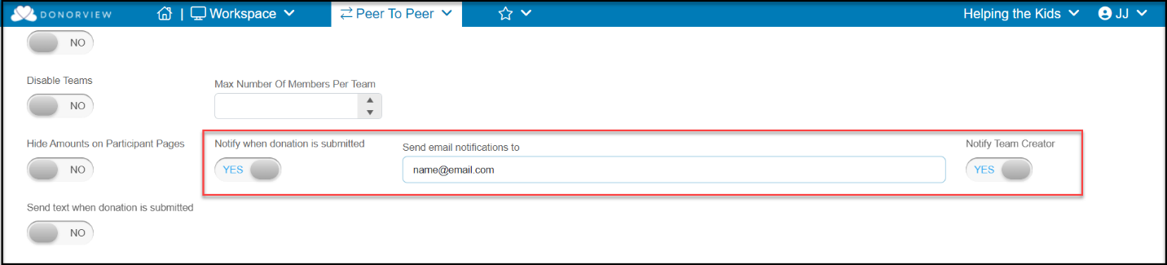

What if I need to change the participant or team that is getting credit for a donation?
- If a participant drops out, you may need to redirect the donation to another participant fundraiser or team.
- You may also need to manually identify a donation link for checks or cash received.
- You can open an existing donation by clicking on the amount donated from the P2P Dashboard’s Details view.
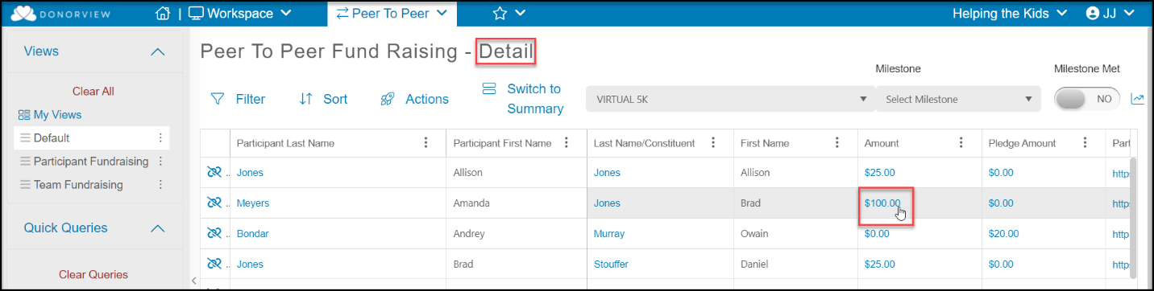
- In the donation record, scroll to the Peer to Peer Gift toggle and select the appropriate fundraiser or team to transfer to donation link to.
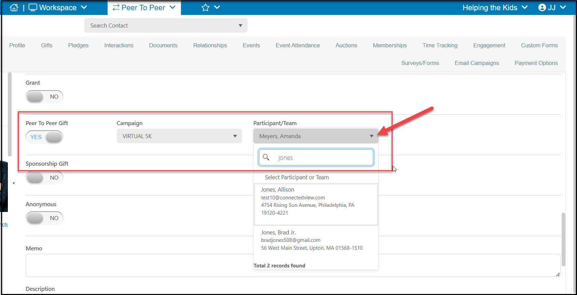

How do I collect the payments for pledges made?
- If you have enabled the Pay later option for donations, they will appear on the P2P Dashboard under the pledge column in the Detail View.
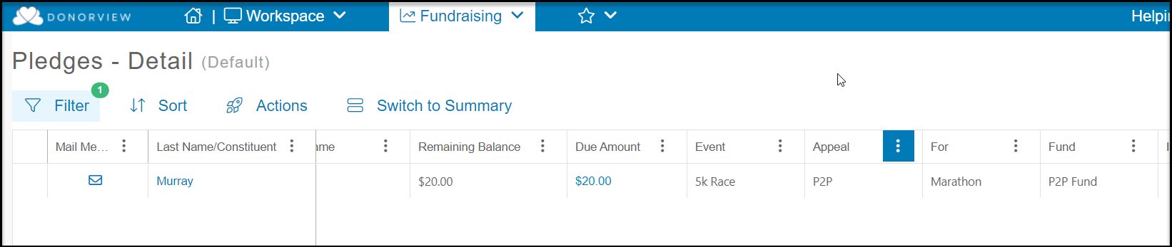
- You can click on the donor’s email address under the Email column (be sure NOT to select the Participant’s Email) to send a direct email message to the donor.
- The direct email message can be customized with merge fields to include pledge amount and due date.
- You also see the pledges for the P2P campaign listed in the Gifts Grid and the Pledges Grid and can send mail merge template letters from the Actions menu in either grid.

Communications

How can I reach out to the fundraisers?
- From the P2P Dashboard’s Detail View, you can create email lists, send direct emails, and text messages using the Actions menu.
- The Detail View will include all participant fundraisers, even those that have not raised any money yet.
- The Summary View only includes fundraisers who have successfully recorded a transaction (like their ticket purchase) or received a donation credited to their page.
- Email lists and messages are sent only to the participant fundraisers, not to donors shown on the grid.

What are the benefits of milestones and badges?
- Creating milestones can help with reporting on the P2P Dashboard as well as keeping fundraising participants engaged in the process.
- The milestones created using the Milestones & Badges page are shown at the top of the P2P Dashboard.
  - You can select the milestone on the Summary or Detail View and see which participants have met or have not met the milestone.
  - To see fundraising participants or teams which have not raised any donations yet use the Detail View.
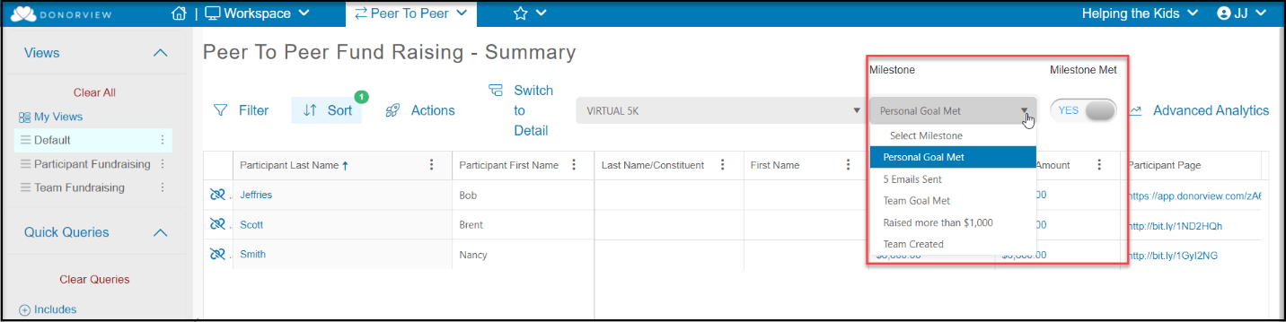
- Setting up a milestone and badge will also automatically notify the fundraising participant or team when they have reached the trigger as well as place a badge on their fundraising page.
  - These notifications give you an opportunity to thank and encourage your fundraisers.
  - The badges also show visitors to the fundraiser’s page how your organization recognizes and appreciates their efforts.

What kind of milestones and badges can I create?
- You can create milestones for your campaign, and some can include a badge to be displayed on the fundraiser's page. See the example below for Brad Jones' fundraising page where the badges he has earned are shown below his Personal Story.
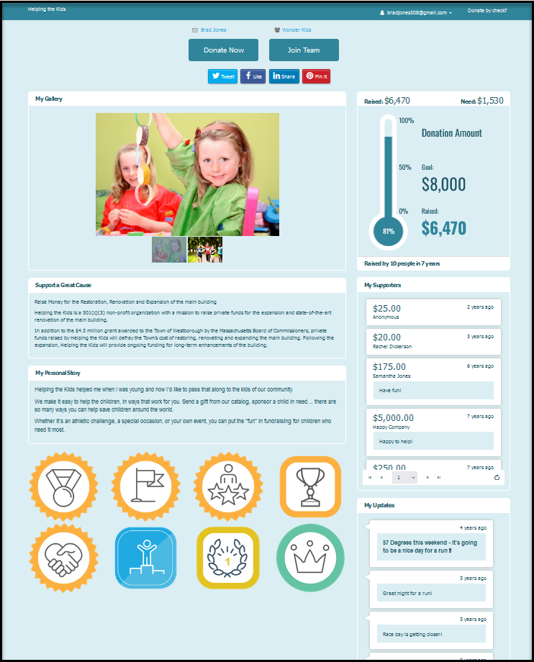
- Hovering over the badge will reveal what was accomplished to earn the badge.
- Milestone and Badges are set up by accessing the page in the P2P module.
- Click on +New to create a new milestone or use the Actions menu to copy an existing milestone.
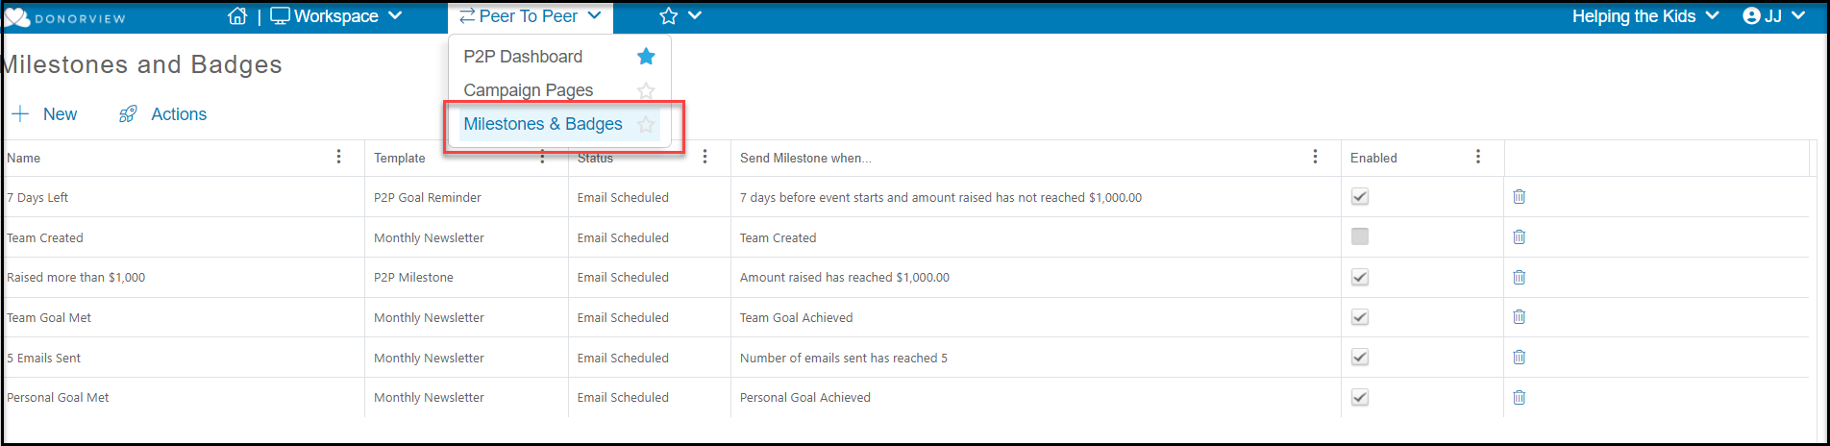
- After completing the Acknowledgement tab information, on the Settings tab you will select which P2P campaigns this milestone will apply to.
- You can import your own image for the badge (file size <1 MB and image size 120 x 120 pixels) or click on Select from Library to choose one that is already created.
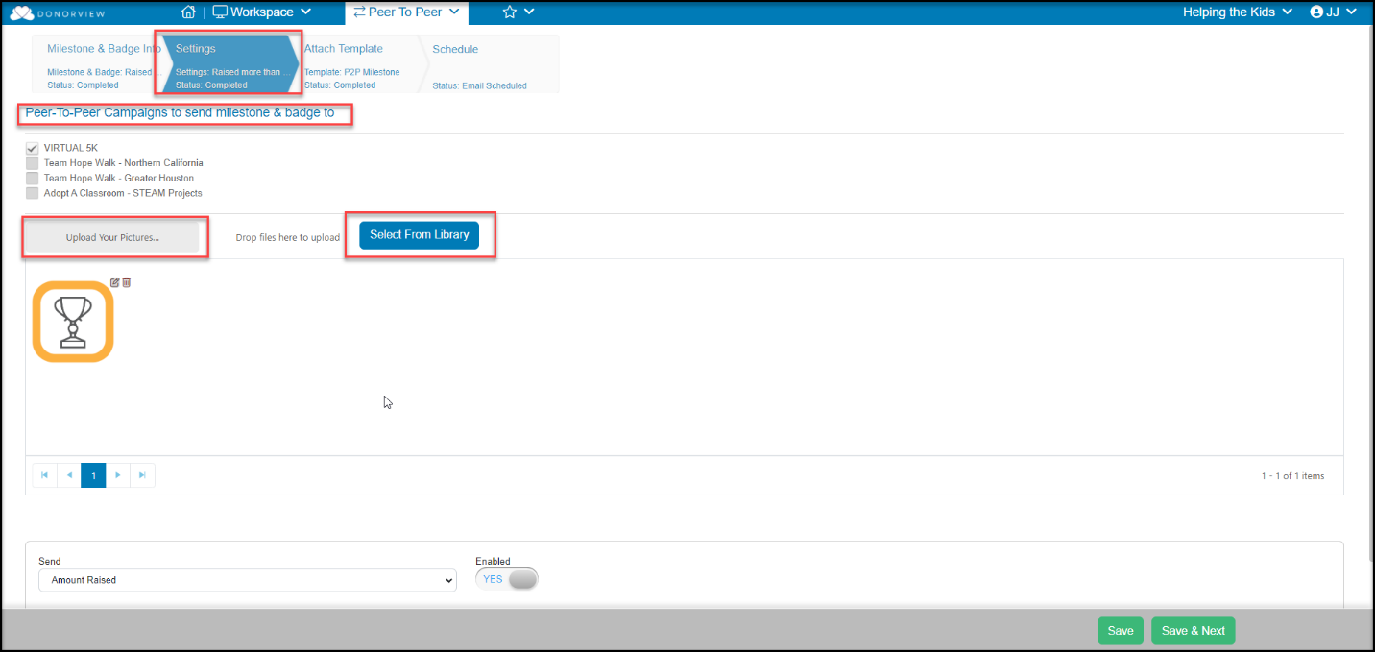
- With your badge image identified, you can select the milestone trigger to generate the message and badge.
  - Amount Raised is the amount of donations raised by an individual participant fundraiser.
  - Amount Raised by Team is the amount of donations raised by the Team and everyone on the team.
  - Number of Days is a trigger to send a notice if the participant has NOT reached their goals. You can read more about this feature in this article: https://support.donorview.com/en/support/solutions/articles/9000237186-how-can-i-notify-fundraising-participants-when-they-haven’t-reached-their-goals
  - Number of Donations is the total number of transactions that have been recorded for that individual participant's page.
  - Number of Emails Sent is the total number of emails that the participant fundraiser has sent using the portal's Send Email feature.
  - Number of Team Members is the number of individual fundraising participants who have joined the team. They do not have to have any donations yet.
  - Percentage Raised is the percentage they have raised towards their fundraising goal as shown on their page.
  - Personal Goal Achieved will recognize when the individual fundraiser reached their fundraising goal.
  - Personal Story Created will recognize entering and saving text in the Personal Story area of the fundraiser's page.
  - Team Created will recognize the creation of a team page.
  - Team Goal Achieved will go to all the team members and the team page to recognize achieving the team fundraising goal.
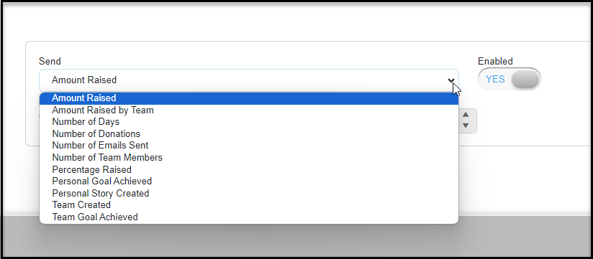
- Be sure to mark the milestone as Enabled YES to activate it.
- You can continue on to the Attach Template tab to create the email template that will be sent when that milestone is achieved or when the reminder is sent that they have not yet reached their goal.
- On the final tab, Schedule, you can send a test email if you would like to check the email template.

How can I notify fundraising participants when they haven’t reached their goals?
- The Number of Days trigger in the Milestones & Badges Setting Tab allows you to notify fundraising participants when they have not achieved specific milestones.
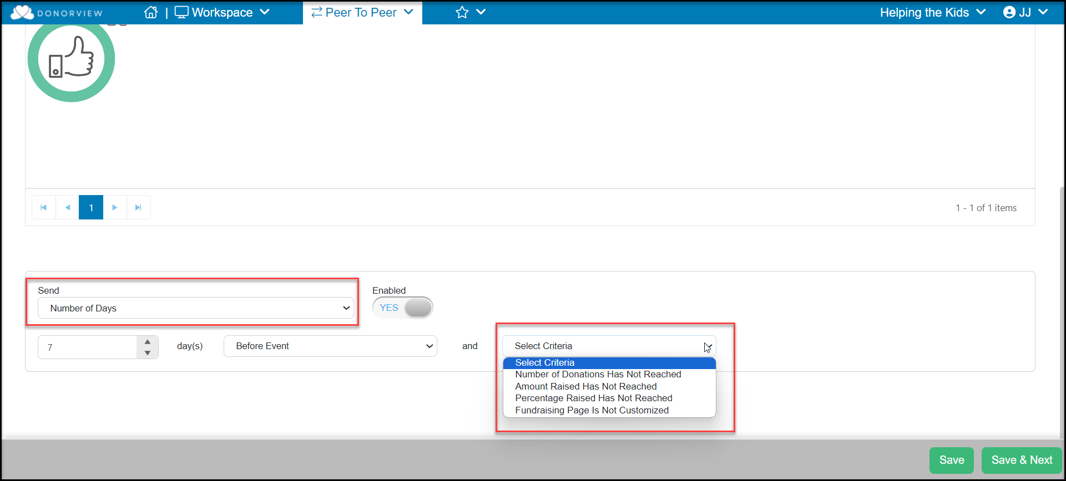
- You will identify the number of days either before or after the event to send the message.
- Note that an event date range must be entered in the P2P campaign page Settings tab to use this feature.
- Choose what criteria under Select Criteria to use and set the Enabled toggle to YES.
- You can customize the email message sent under the Attach Template tab.
- On the Schedule tab, you can also send a test email if you’d like to verify the links and check spelling.

What are the options for sending thank you acknowledgments to P2P donors?
- Each donor will receive an automatic thank you message you create in the P2P Campaign page.
- You can customize the message and include things like links to your webpage where you are sharing the progress widgets for the P2P campaign.
- Setting up your P2P campaign, you should also identify the For-Fund-Event-Appeal as applicable.
- You can see all donations to a particular For-Fund-Event-Appeal on the Gifts Grid and use the Actions menu to send additional thank you acknowledgements using the Mail Merge feature.

Reporting

What is the difference between the Summary View and the Detail View on the P2P Dashboard?
- The summary view shows the total donations received for a specific fundraiser or team in the Amount column.
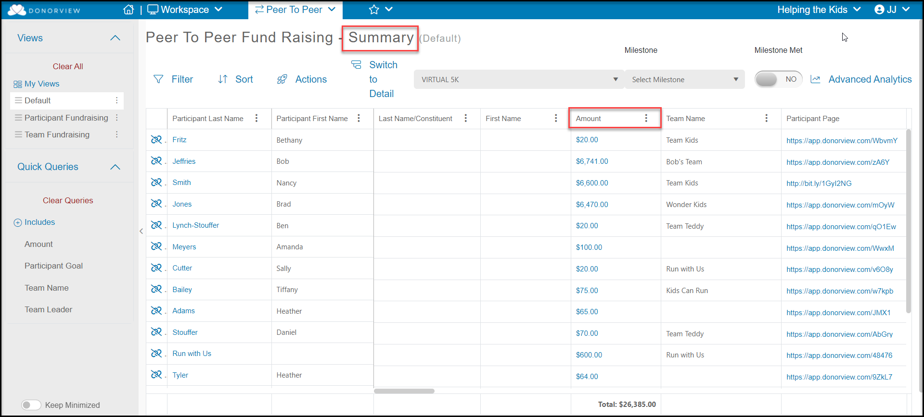
- The detail view shows each contribution linked to the P2P campaign.
  - The donor’s name is shown in the Last Name/Constituent column and the page the donation is linked to under the Participant Last Name column.
  - Teams also become constituent’s and any donations made specifically to a team will be shown linked to the team name.
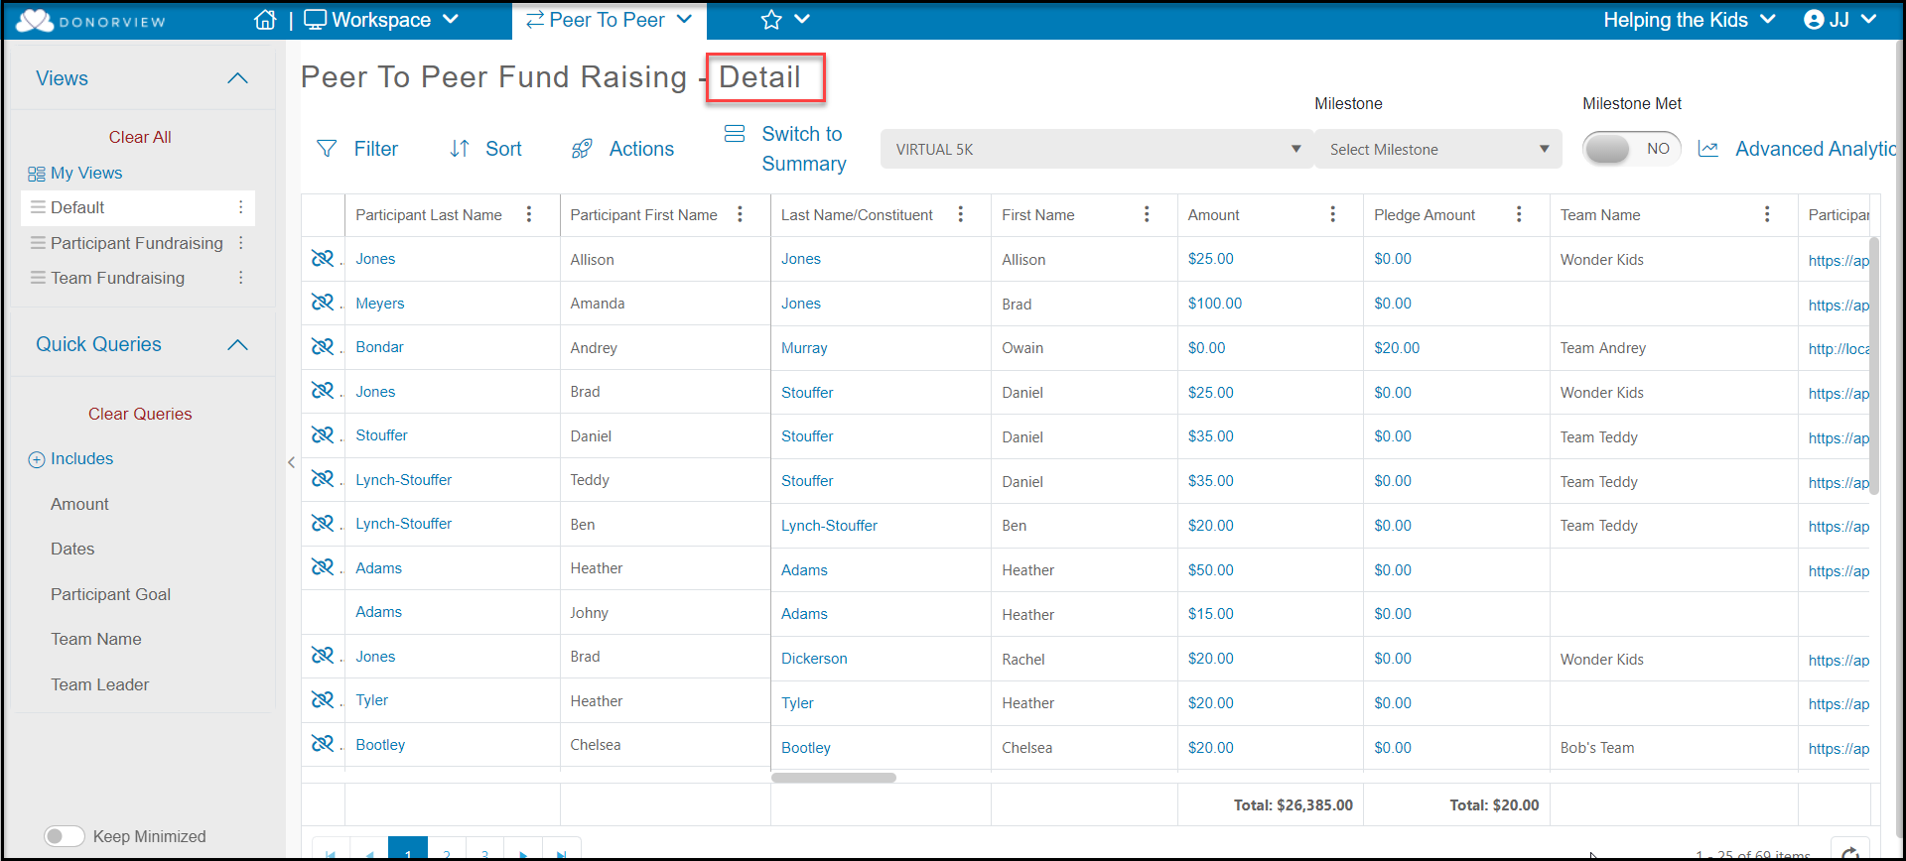

How do I see all the donations for a P2P campaign?
- The P2P Summary Dashboard found under the Workspace menu shows graphs for the most current P2P campaign.
  - The entire dashboard can be exported as a pdf file using the icon in the top right corner of the screen.
  - The individual graphs can be exported as a pdf or image file using the icons in the top right corner of each graph.
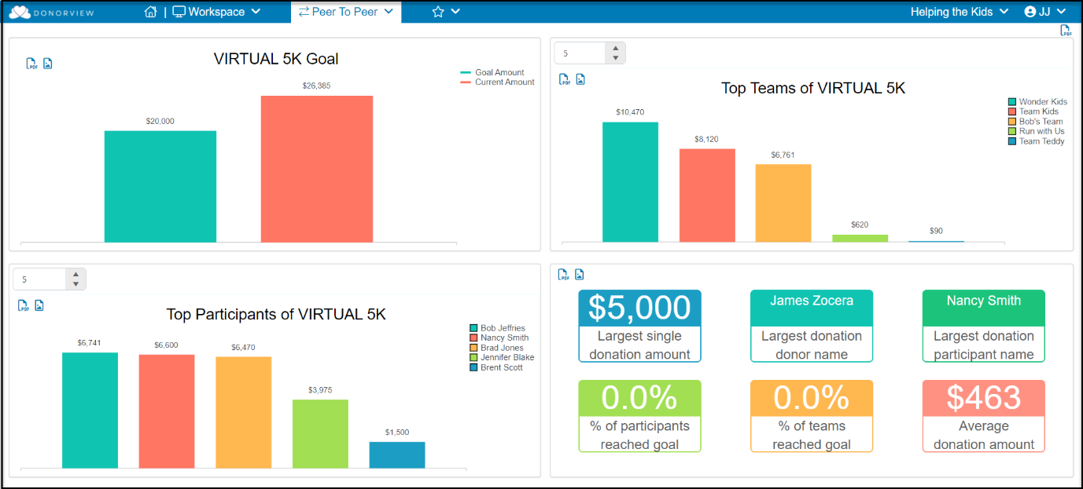
- The total raised so far for the campaign is shown under the Amount column.
- The P2P Dashboard Detail view will show each individual donation or pledge.

How do I see the money raised by the team?
- To see the total raised by each team, export the data from the summary view to Excel.
- Sort the Team Name column by clicking on the column or using the Sort feature.
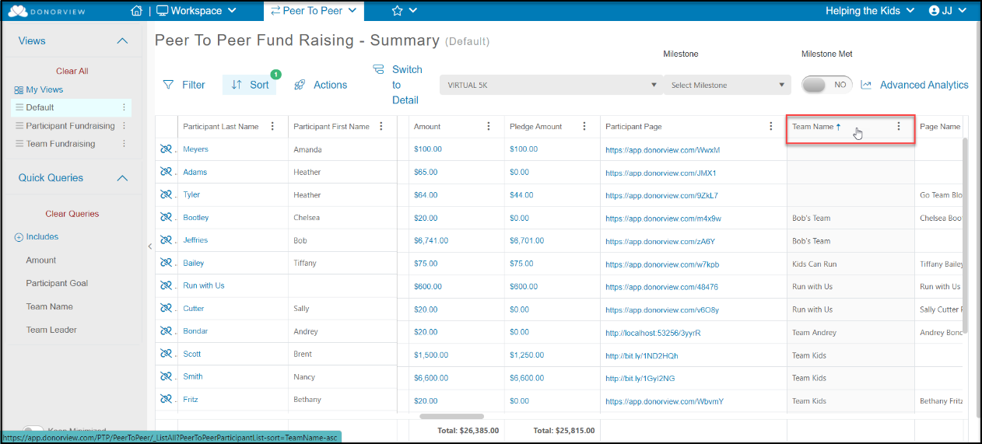
- Export the data to Excel using the Actions menu.
- From Excel, you can sum the amounts for each team.

