This document provides an example to share with your fundraisers for building and promoting their pages. You can update this document with your own links, images, instructions, and contact information.
Creating Your Page(s)
- Click on the link to sign up or sign in to create your fundraising page. ENTER YOUR LINK HERE
  - If you already have a portal account, you can click on SIGN IN or Already have an account, click here to login to your existing account.
  - If you do not have an account, you will create a password, then re-enter your password and click on the orange Sign Up button.
  - From the sign in page, enter your email and password and click on Sign In.
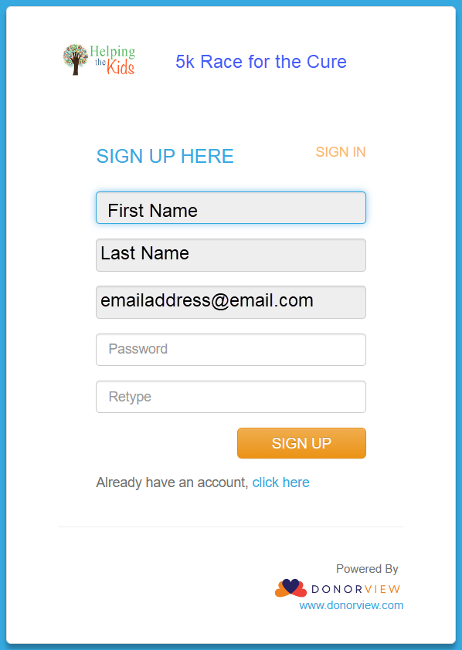
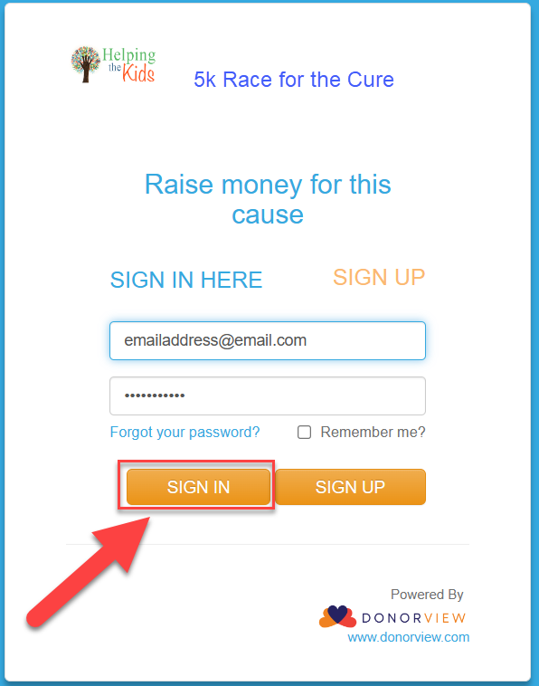

- When you enter the portal, you will be able to create your personal page first.
- If you are the team leader, you must create your personal page before your can create your team page.
- If you have not joined a team, after you create your personal page, you have the opportunity to join a team or create a new team if you’d like to.
- Enter your page name, goal amount, a goal chart title, and your personal story. You can edit these anytime. Click the blue SAVE button to create your page.
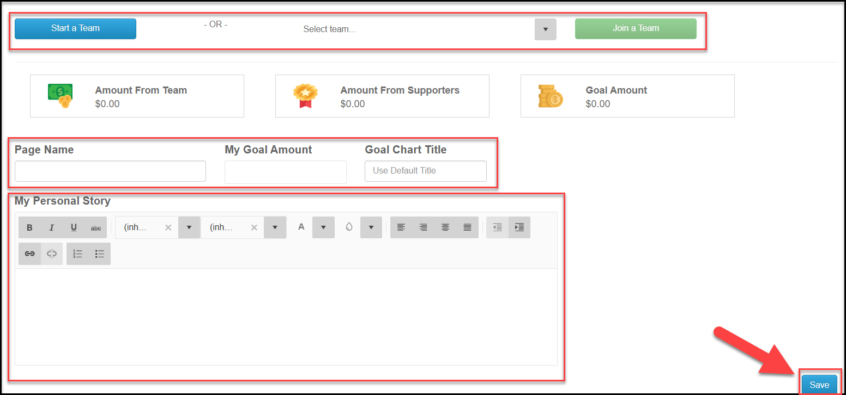
- With your new page created, you can share the URL link to your page, download a QR code to share, and, if enabled, you can create a text code.
- Your personalized text code is an alpha-numeric code word (no spaces) that donors can text to the nonprofits text-2-give phone number XXX-XXX-XXXX and the donor will receive a link back to your fundraising page to make their donation using their phone.
- After the page is created, you also have the option to update the color theme.
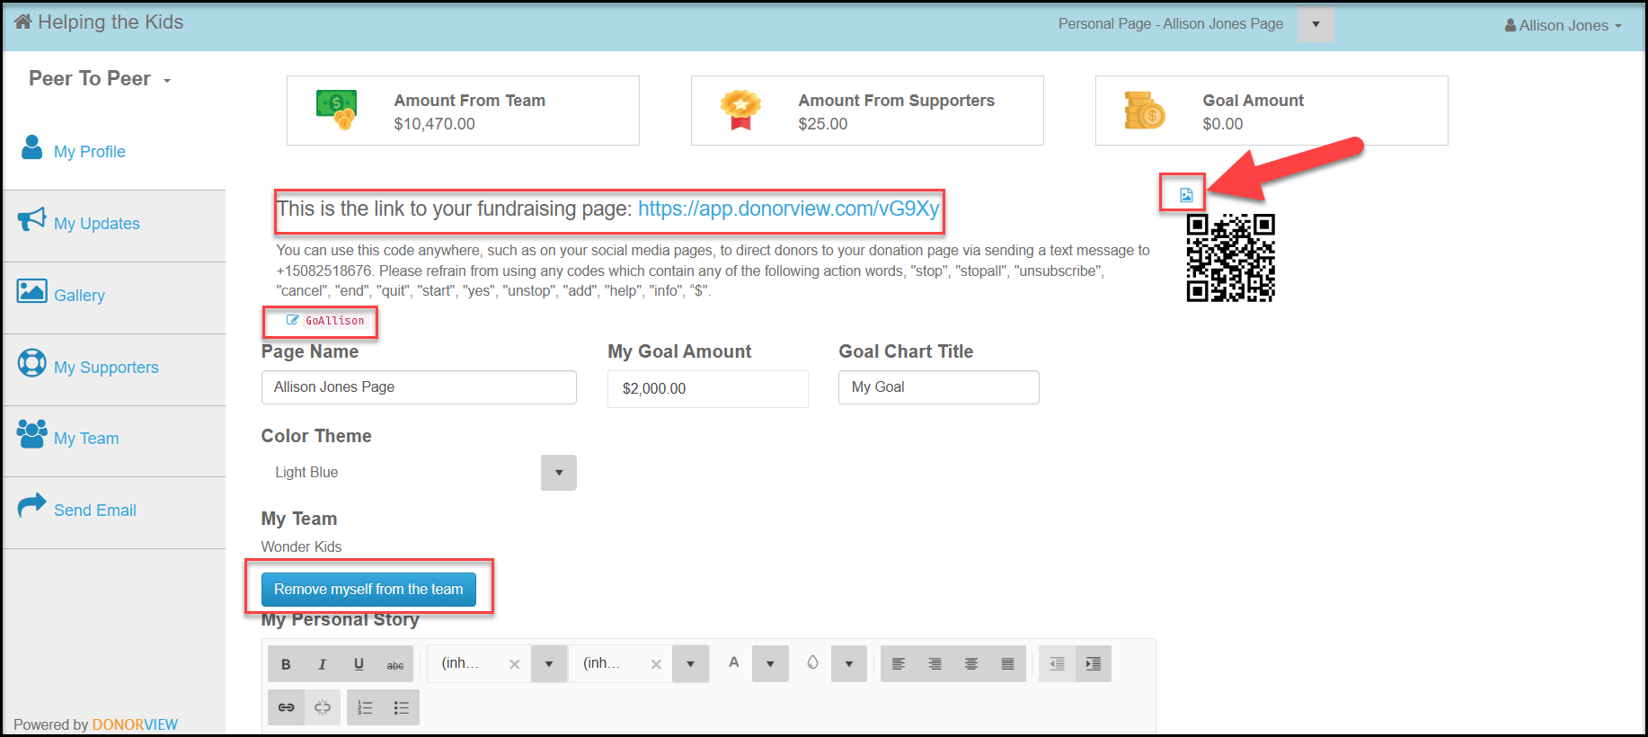
- Scroll to the bottom of the page to see a preview of your page and make edits as necessary.

- Click on the link to you page to see it live.
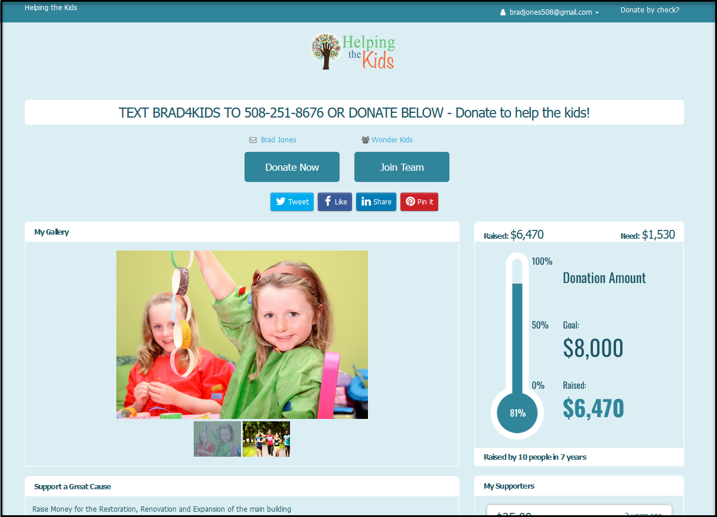
- If you are the team leader, you can see the team you created using the page menu at the top of the page.
- Clicking on the team name will allow you to edit the page as above.
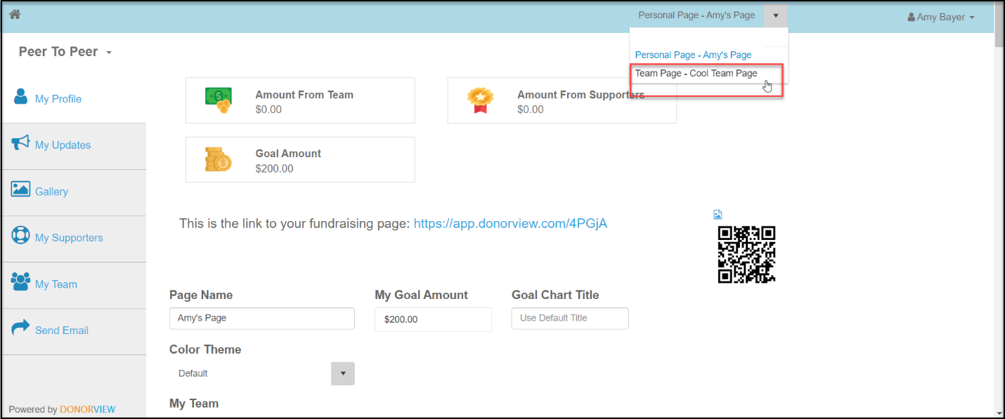

- If your team has not been created yet, click on the blue Start Team button.
- Enter the team name and goal for the team and click the blue Save button to create the team page.
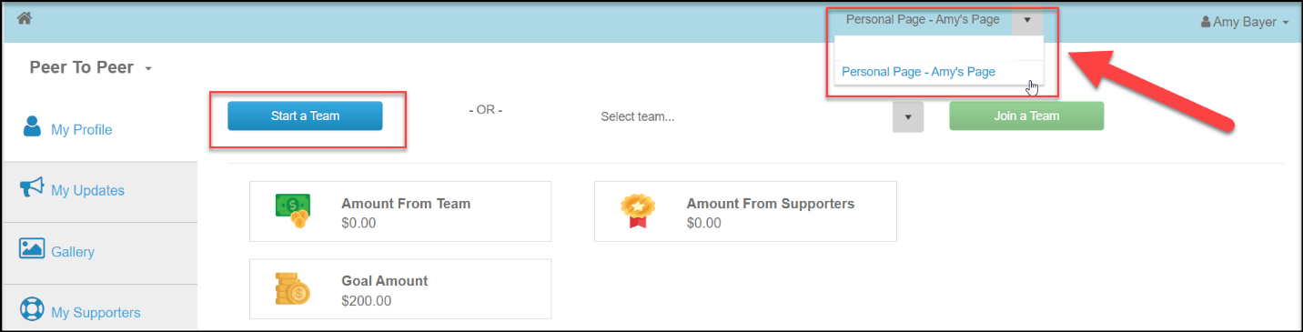
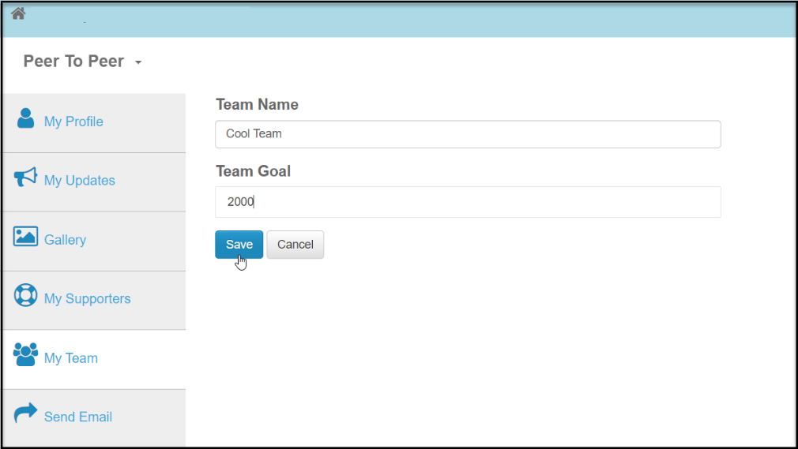

Customizing and Sharing Your Fundraising Page(s)
- The menu on the left side of the page allows you to customize information and communicate with donors and potential donors.
- You can add your own updates to your page using the My Updates link.
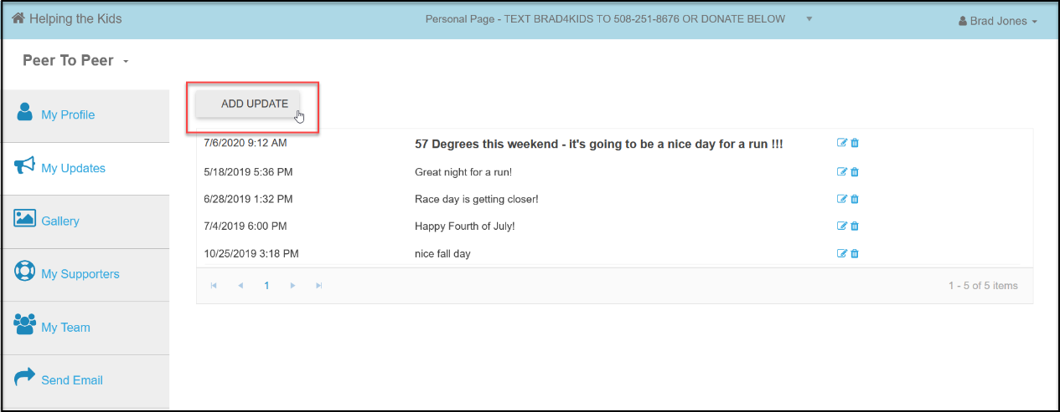
- You can upload your own photos and a YouTube video using the Gallery link.
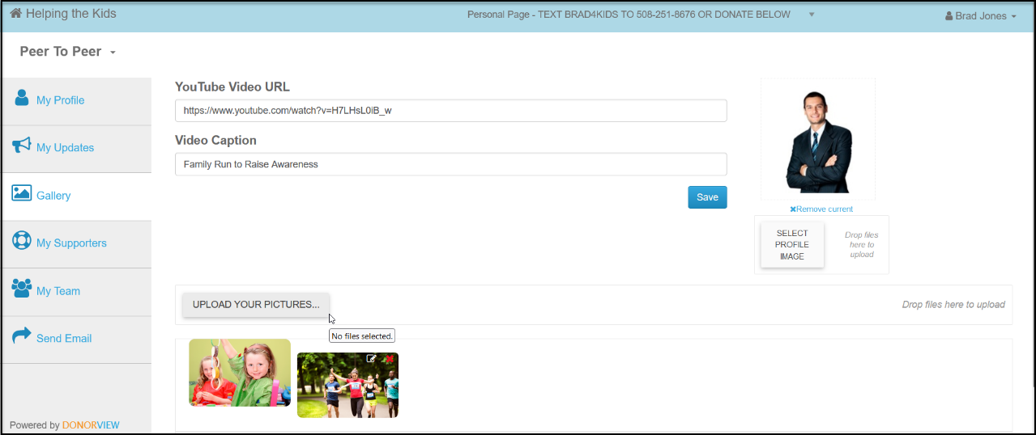
- When donations are made on your pages, you can see information about the donors and even send them messages using the My Supporters link.
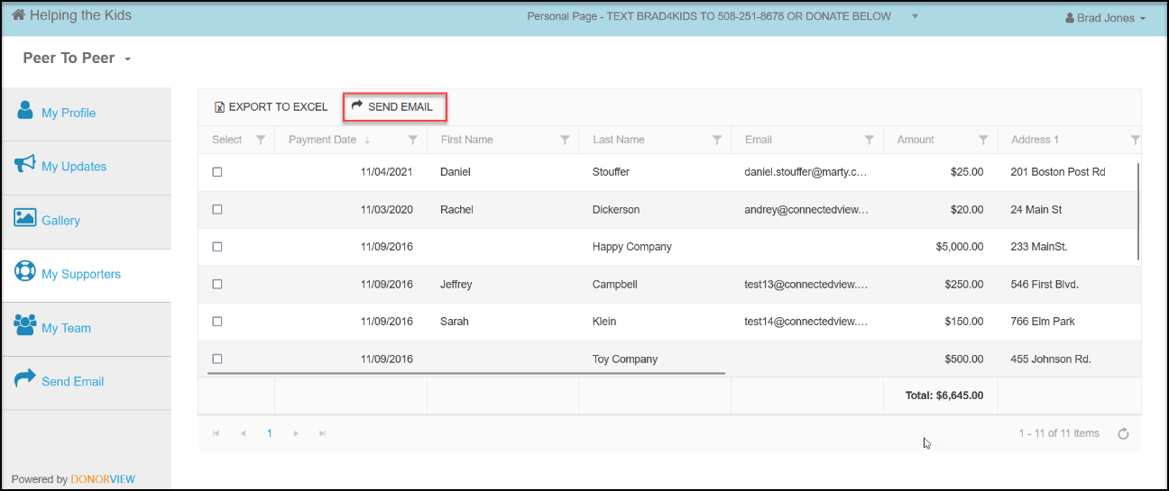
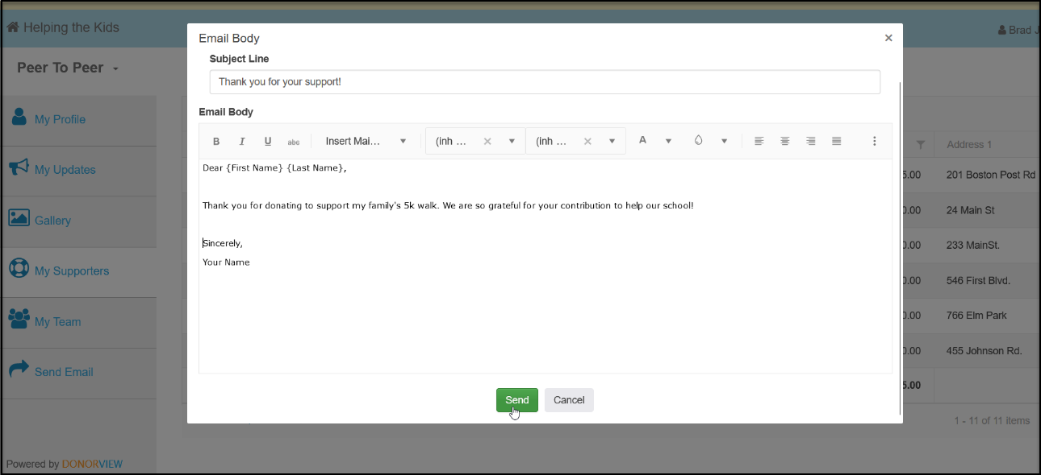

- You can see how your teammates are doing with their fundraising in the My Team link.
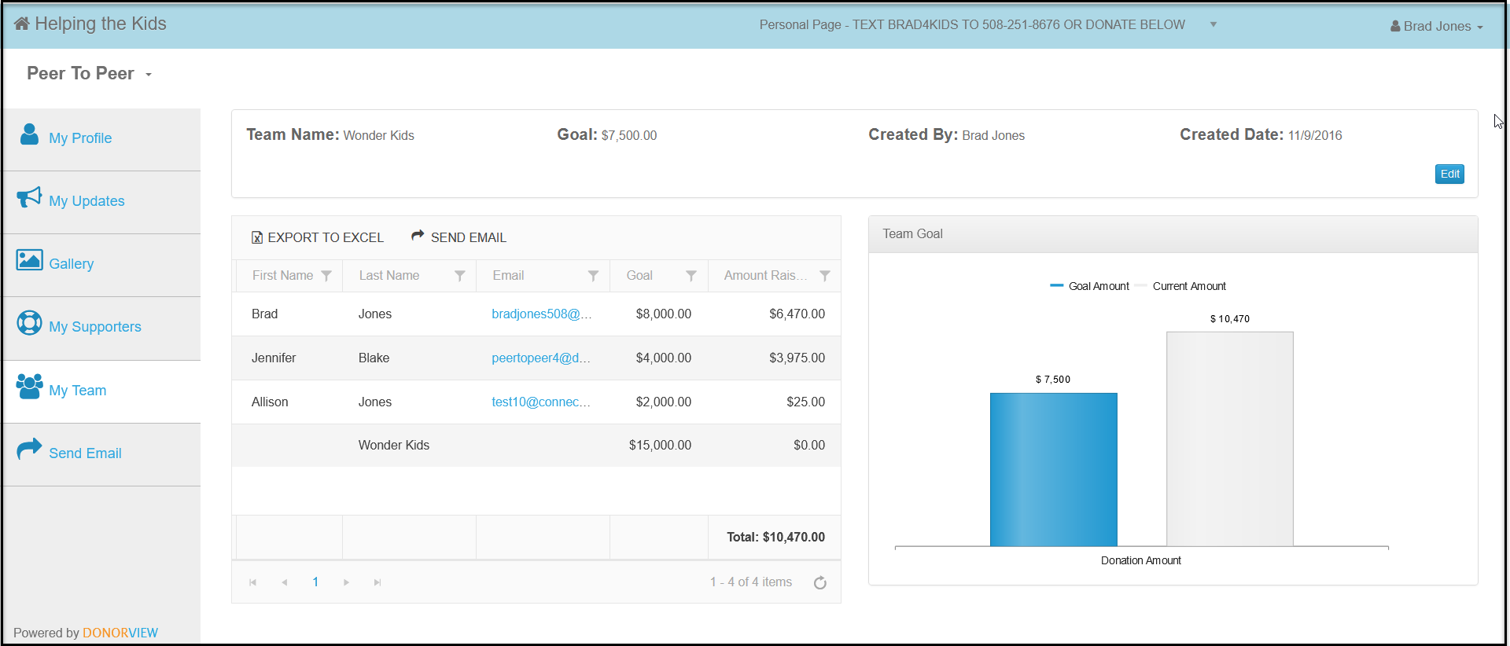
- You can also share your links and send emails to your friends and family from the portal. The emails are sent under blind copy, so you don’t have to worry about anyone seeing any email addresses.
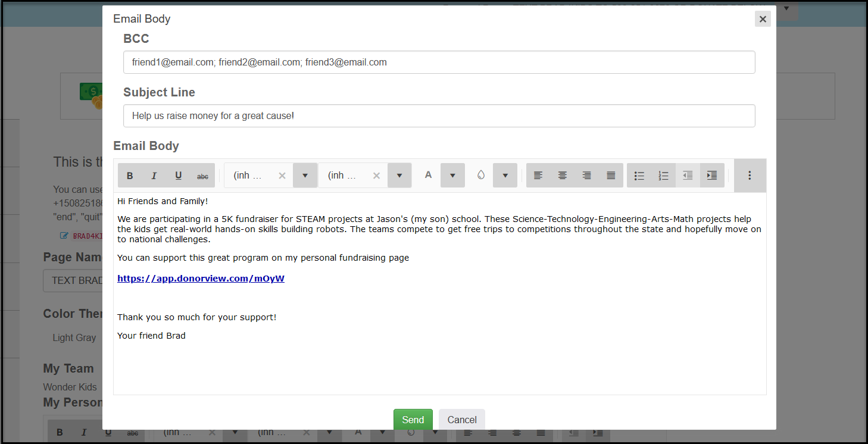
- You can also share your page links via your personal email, social media, and text messages.
- INSERT ORGANIZATION NAME will be recognizing our top teams and fundraisers by INSERT YOUR MILESTONE AND BADGE PROGRAMS AND ANY PRIZES.
- You can see how the other teams and fundraisers are doing on our website at INSERT YOUR WEBPAGE WHERE THE PROGRESS WIDGETS WILL BE SHARED.

