Adding & Updating Payment Information in DonorView

Go to the Payment Options tab on the constituent record. This will show all saved payment methods and allow you to add or delete payment methods.
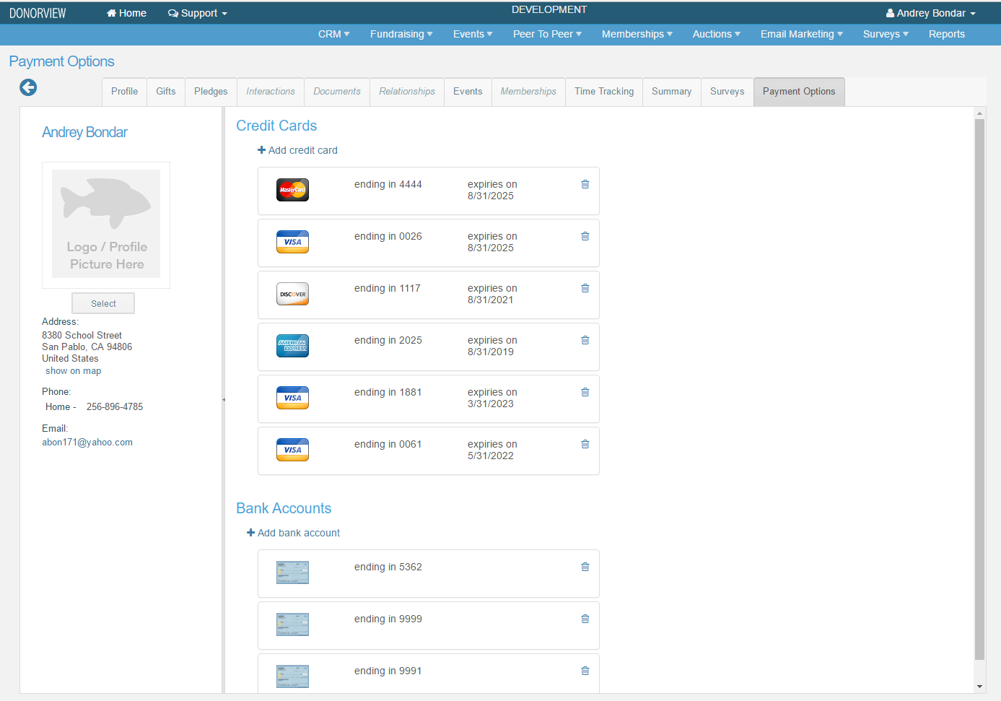

To delete a payment method, click on the trash can icon for that payment method.

To add a payment method, click on either Add credit card or Add bank account.

For a credit card payment, the entry screen looks like this. Fill out the information & hit Save. If you want to update the address & have it go to the constituent profile, be sure to select Yes for the option “Use this address to update the profile?”.
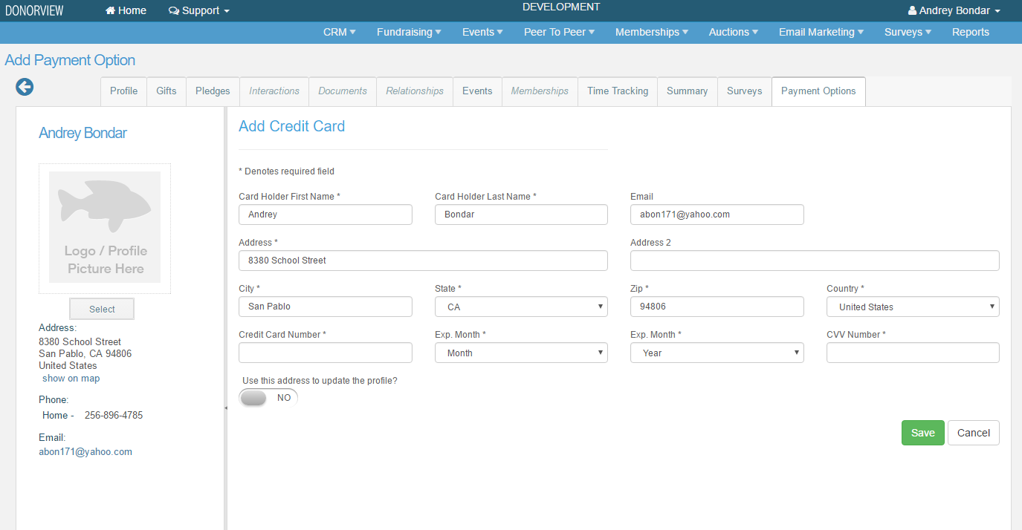

For a bank account/ACH payment, the screen looks like this. Fill out the information & hit Save. If you want to update the address & have it go to the constituent profile, be sure to select Yes for the option “Use this address to update the profile?”.
